State of Lone Star
vs.
Willy Williamson

Texas Tech University School of Law Board of Barristers
Fall 2025 Advanced Mock Trial Competition

Prepared by: Mock Trial Committee

INTRODUCTION

Late May 16, 2025, Willy Williamson, and his friend, Robert Chandler, were drinking at Grasshopper’s, a local bar. After several drinks, Williamson decided to head home. Williamson lives in the HEDGE Apartments which is located across the street from Flashton Pointe Apartments, an identical but separate complex. Montgomery ended up taking Williamson to the wrong complex. Upon entering the wrong apartment, leased by James Michaels, Michaels struggled with Williamson in an attempt to get him out of the apartment. In the process, Williamson stabbed Wrigley with a knife.

The applicable law is contained in the statutes and proposed jury instructions at the end of the case.

The Prosecution must call:

James Wrigley

Officer Trace Richards

The Defense must call:

Willy Williamson

Robert Montgomery

STIPULATIONS

1. The only citable authority in this jurisdiction are the Federal Rules of Evidence, Federal Rules of Criminal Procedure apply, and any prior court orders for this cause number. Outside case law or other relevant authority is not permitted to be used during argument, motions, or evidentiary matters. Objections based on Crawford v. Washington and Melendez-Diaz v. Massachusetts will not be entertained.

2. Motions in Limine shall be limited to five minutes per side.

3. Although this problem may reference a witness as “he,” “him,” “she,” or “her,” all witnesses
are gender neutral and can be portrayed by a male or a female.

4. All witnesses called to testify who have identified the parties, other individuals, or tangible
evidence in Affidavits can, if asked, identify the same at trial.

5. All Affidavits were signed and taken under oath.

6. No witness may claim that they did not swear under oath to tell the truth during his or her
deposition, and no witness may claim they did not have the chance to correct any inconsistencies
before signing the deposition.

7. For this competition, no team is permitted to attempt to impeach a witness by arguing to the
jury that a signature appearing on a deposition does not comport with signatures or initials
located on an exhibit.

8. Other than what is supplied in the problem itself, there is nothing exceptional or unusual about
the background information of any of the witnesses that would bolster or detract from their
credibility.

9. This competition does not permit a listed witness, while testifying, to “invent” an individual
not mentioned in this problem and have testimony or evidence offered to the court or jury from
that “invented” individual.

10. “Beyond the record” shall not be entertained as an objection. Rather, teams shall use cross-
examination as to inferences from material facts.

11. All exhibits in the file are authentic.

12. The State and the defendant must call the two witnesses listed on their respective witness list.

13. No additions are permitted to the provided jury instructions.

SUBSTANTIVE MATTERS

1. Willy Williamson has entered a plea of not guilty and has requested a trial by jury.

2. The trial court has denied a motion to dismiss the indictment.

3. The State and the defense have agreed to an “all or nothing” verdict; therefore, no lesser-
included offenses may be argued to or considered by the jury.

4. The unchained key recovered from Mr. Williamson’s pocket was confirmed to be Mr. Wrigley’s apartment key.

5. The baggie recovered from Willy Williamson by Officer Trace Richards was tested and
contained 2.4 grams of marijuana.

6. The State of Lone Star does not adhere to the Castle Doctrine in any form.

7. It is no dispute that HEDGE Apartments and Flashton Pointe are, for all purposes, identical
apartment complexes.

8. The blade on the pocketknife recovered at the scene was measured to be 2 inches in length.

9. The pocketknife recovered at the scene belongs to Willy Williamson.

10. Willy Williamson has properly raised the affirmative defense of Self-Defense.

Case No. CR 4219-12
THE STATE OF LONE STAR  vs.  WILLY WILLIAMSON  Defendant, | §  §  §  §  §  §  §  §  § | IN THE DISTRICT COURT  IN AND FOR  ARMADILLO COUNTY, LONE STAR
INDICTMENT
July 2025 Term

THE GRAND JURY CHARGES THAT:

COUNT ONE
(Criminal Trespass)

- On or about May 17, 2025, in Flatland, Armadillo County, State of Lone Star, Willy Williamson did enter and remain on or in the property of another without effective consent of the property owner, having notice that the entry was forbidden and receiving notice to depart but failing to do so.

COUNT TWO
(Aggravated Assault)

- On or about May 17, 2025, in Flatland, Armadillo County, State of Lone Star, Willy Williamson did commit assault, in that he intentionally, knowingly, and recklessly caused bodily injury, on another person while using and brandishing a deadly weapon during the commission of the assault.

******************
A TRUE BILL
******************

Luke Stump
GRAND JURY FOREPERSON

RACHEL BEHNKE
ARMADILLO COUNTY DISTRICT ATTORNEY

By: Isabella Golemi
Isabella Golemi, Assistant District Attorney
My name is James Wrigley, and I live in Flashton Point Apartments at 1650 S. Taney Place, Apartment 523 in Flatland. I am forty-six years old and live with my wife, Kathy, and two children, Dana and Tony. I work for the City Bank of Flatland as a security guard.
I really enjoy being a security guard. I’ve been doing this now for quite a while, just about 10 years. It’s very rewarding to me, because I get to protect people. I never really wanted to be a police officer, because I have two children and I cannot put myself in a daily situation where I might not come home. See, police officers have a big risk every single time they pull someone over. Us security guards, though, it’s not so bad—bank robberies are incredibly rare. In fact, in the 10 years that I have worked at City Bank, I have never personally seen a bank robbery.
Even if an emergency were to arise, though, we have all been properly trained. We all go through a firearm safety course before anything else. Guns are our last resort. Even when we have to use our guns, we are never supposed to shoot to kill except in the most exigent circumstances. Thankfully, I have never had to use my gun. We are trained to avoid physical contact and force as much as possible, too. Our first mission is to always try to talk to the guy robbing the store. There are women and children present in the bank at all times of the day, and so we are trying to keep the entire situation calm so as to not freak them out. Think about it—if we were told to just go after anyone who was robbing, or who we suspected of robbing the bank, we would hurt innocent people and scare the other customers. So instead, we are told to negotiate. If negotiations do not work, or if the person is armed, then we draw our weapon and hope that all hell does not break loose. Like I said before, though, luckily, I have never had to worry about any robbers.
On May 16, 2025, my daughter Dana left on a date with her boyfriend. She had a midnight curfew. I usually wait until my daughter gets home before going to bed. However, my daughter did not get home on time or call and tell me she would be late. I hate it when she does that. I think her boyfriend is a no-good lowlife of a boy, though, and convinces her to stay out to break my rules. I do not approve of him at all, and in my opinion, he has always tried to pretend he is some kind of rebel. It goes without saying that I was upset with her and expected an explanation or I would ground her.
Normally I keep all of the doors locked even when we are home. Dana used to have a key but she lost it at school a few weeks ago. I have not gotten around to making her a new copy of the apartment key, so that night I left my key under the mat so she would have a way to get in if we were not home. Or if she came home at all. When my daughter did not come home at midnight, I went into the bedroom to get ready for bed. One of the windows in my bedroom faces the parking lot, and I was able to watch for my daughter. My wife stayed in the bedroom along with me while we waited for Dana. I decided to watch the TV for a little bit so I could catch the late-night news. My wife was reading that new novel that women everywhere are reading: A field of stickers and tulips. I have never read that book, but I already do not like it. My wife always compares me to the antagonist. I was already in a bad mood because Dana was not home on time, and my wife put me in an even worse mood by bringing up that ridiculous book again. I just focused on the news and tried to ignore her.
Just a little bit before 12:30 a.m. we could hear loud footsteps coming up the stairs to where our apartment’s door was. I heard what sounded like some keys fumbling around with the lock on the door, and we just figured it was Dana. Sure enough, after a small pause, I heard the front door unlock and open up.
As I left my bedroom, I saw the light come on and could see a person standing in the entryway of the apartment. He was looking around the apartment and we made eye contact. At this point I yelled out and ran toward him and tackled him back outside onto the walkway.
I yelled to my wife to stay where she was and the person started struggling with me. I kept yelling to my wife to call 911. The person under me continued to struggle with me, and at this point I really wanted to get off of him and to get inside my apartment so that my wife and son, Tony, would be okay. He kept wriggling and squirming, and so it was difficult to get up. At one point I tried pushing myself up off of him, hoping to get away and get back inside.
At that point I felt a very sharp pain shoot through the left side of my stomach. The pain was so intense that I cried out and immediately fell over. That was when I noticed I was bleeding badly and, putting two and two together, figured I had just been stabbed. Luckily, this is when the police showed up. The paramedics showed up not long after that and began patching me up.
One of the officers introduced himself as Trace Richards, and I told him who I was and that the other guy had walked into my apartment, and I tackled him out the apartment and tried to keep him away from the door while the police were called. I believe that my wife was able to show the officers some identification so that they knew we lived there and that he was breaking in and told Richards about what happened as well. He seemed more concerned about getting me to the hospital and told me that he would talk to me further once I was okay.
I was in a lot of pain while speaking with the police, but I never lost consciousness. The paramedics were attending to me the whole time and eventually I was placed on a stretcher. I didn’t think I was bleeding so badly at this point, which made me happy. The paramedics told me that it did not look like it was too bad of a wound, and that I actually was not bleeding that much—it just appeared like a lot because of the shirt absorbing it.
After I spoke with Officer Richards, I saw them search the other person. The police found his wallet, some car keys, and a small baggie that appeared to contain marijuana. The police identified the person as Willy Williamson and asked me if I knew him. I told the police that I had never seen him before.
The crime lab also showed up and took away the knife that I was stabbed with and took some photos of the apartment and the outside area where we struggled.
I was taken to Flatland General Hospital, where the doctors took a look at the wound. Officer Richards arrived a short time after that, but because I was being prepped for surgery, I was not able to talk to him any further. Apparently, the stab wound wasn’t too deep, and after surgery I was told it didn’t do any permanent or serious damage to my insides. I was stitched up and sent on my way the following afternoon. I missed a little bit of work since the attack, but once the stitches came out it was back to the grind. I haven’t had any serious physical side effects because of the attack either; just a scar on my stomach.
Officer Richards called me on Monday, May 20, 2025, to get some more information out of me. I told him about how I was watching TV with my wife, how Mr. Williamson opened the door and walked into the apartment, was looking around the room, and how my first reaction was to tackle him and keep him out of my apartment. After we discussed the incidents of that night, he asked me if I wanted to file any charges against Mr. Williamson. I told him that I wanted to charge him with everything he could be charged with. You can’t just walk into someone else’s home and get away with it! I’m just happy that Tony and Dana did not have to see anything, and that none of them are hurt.

James Wrigley
I certify that the above is a true and accurate transcript of the deposition of James Wrigley taken this the 19th day of June, 2025.

Derek Fisher
Derek Fisher
Certified Court Reporter
My name is Trace Richards, and I am an officer with the Flatland Police Department. I have been with the police department for about 12 years now. I started off like any other officer and was given patrol duty. Now, and for the past 4 years, I do a mix of patrol work and crime scene investigation. When I arrive at any crime scene, my first task is to speak with any witnesses and parties involved. After that is done, I assist with the rest of the crime lab in forensic investigation. I usually combine the witness investigations and the forensic investigations into a single police report.
On May 16, 2025, I received a dispatch concerning a stabbing at 1650 S. Taney Place in the Flashton Pointe Apartment Complex. I received the dispatch at 12:29 a.m. and was patrolling the area, so I was able to quickly respond and arrived at the Flashton Pointe Apartments at 12:31 a.m. I was familiar with the area because this was not the first time, we have received a call about someone being in the wrong complex. Flashton Pointe and HEDGE, although placed directly across the street from each other and being classified as two separate apartment units, they look exactly the same. I am not sure if they were designed to be the same or not, but we’ve received many calls about trespasses or people trying to get into the complex because they think it’s the other one. I think the problem is made worse by the fact that neither complex is gated.
When I drove up to the apartment and arrived at the proper unit, I saw one person standing against the wall, who was later identified as Mr. Williamson. There was another person lying on the ground with blood covering the abdominal region of his shirt, and he was later identified as Mr. Wrigley. Wrigley’s wife was also there, and she informed me that Williamson had broken into their apartment, Mr. Wrigley yelled at Mr. Williamson to leave, and that Williamson stabbed Mr. Wrigley.
Mr. Wrigley was in obvious pain, so I instructed him to just lie still and wait for the ambulance to arrive. I left my partner with Wrigley so that I could speak with Williamson about what happened. I gave a quick look at Mr. Wrigley and noticed that no blood was spurting or flowing out of his stomach. I also did a quick examination of Williamson, who didn’t appear to have any obvious injuries. I like to do this so that I can write a physical description of the persons involved in my reports.
Williamson told me that he and a friend of his named Robert Montgomery had been drinking at Grasshopper’s, but since the night seemed like it was going to be uneventful, they decided to head home. Williamson’s friend, Montgomery, drove Williamson back to his apartment.
Williamson told me that he lives in the HEDGE Apartment complex, and his driver’s license confirmed this. Obviously, Wrigley lives in the Flashton Pointe apartments, and this is where all of the confusion came from. Montgomery came up to me at this point and said he would be willing to offer any information that he could, which I welcomed. Montgomery indicated that he gets confused with the two apartments sometimes, and that since it was night, he turned left into what he thought was the correct complex. I asked him what he was still doing in the parking lot of the complex, and he told me that he had been texting another girl at the time and was listening to music, when he thought he heard a person yell. Williamson indicated that he was not paying any attention to where Montgomery was driving at the time. At the time this was happening, I could detect an odor of alcohol on Williamson, and only faintly on Montgomery.
Williamson indicated that he got out of the car and went up to what he thought was his unit— unit number 523. After neither of Williamson’s keys would work, he checked for the key he always keeps under the welcome mat. Upon finding the key, he unlocked the door, went in and turned on the light. Williamson informed me that after he turned on the light, he immediately realized that he was in the wrong apartment and attempted to leave before Wrigley tackled him back outside. According to Williamson, Wrigley began attacking him. At one point, according to Williamson, Wrigley pushed his arm into Williamson’s head to try to pin him there, which is when Williamson was able to grab his knife and stab Wrigley with it.
Shortly after this conversation, the rest of the crime lab arrived and took possession of the knife. They also took pictures of the scene.
By this point the ambulance had arrived and had nearly finished bandaging Wrigley up. He seemed like he was in less pain, and I went over and asked if he was OK to answer a few questions. I asked Wrigley what happened, and he told me that he and his wife were in bed when he heard what sounded like keys fumbling around with the deadbolt on his front door. After a brief pause, he heard a key enter the lock and open the door. Williamson indicated that he told his wife to stay in bed as he went to investigate. Wrigley then briefly told me that Williamson had walked into their apartment and that Wrigley saw Williamson standing in the living room. Upon seeing Williamson, Wrigley told me that he shouted at Williamson and charged him out of the apartment. By this point, the paramedics were ready to transport Wrigley to the hospital, so I let them go.
I attempted to talk to Kathy Wrigley a bit more, but she was too upset to give any further statement.
It seemed pretty clear to me what happened here, so I asked Williamson if I had permission to search his body, which he granted. We recovered a set of keys; a single, unchained key; a wallet containing a driver’s license and a receipt from Grasshopper’s; and a small baggie of marijuana. Because of the marijuana, I went ahead and placed Williamson under arrest. Given that I could detect alcohol and a fight had occurred, I went ahead and had my partner take Williamson to the hospital so that he could be examined as well. I told my partner that he needs to let the hospital know to draw Williamson’s blood to run an alcohol test on it.
Before leaving the scene, I decided to do some examination of my own. I enjoy the Crime Scene Investigation side of my job a lot. It is a good break in the monotony that can be typical patrolling. It also really lets me get into the scene and try to picture what happened. I examined the door, and there was no obvious sign of any forceful entry. The frame was intact, and there were no shards or splinters in the immediate area. Flatland is a very dusty city, so most sidewalks, roads, and walkways are covered in dirt. There was displacement in the dirt that had settled on this walkway. There were the typical footprints going to and from each door, but outside of the Wrigley’s door was a large, ovular displacement. I could not find any handprints in the dirt.
I went to the hospital to check on the condition of Wrigley. I was told that he was being prepped for surgery but that his life was not in danger. I was told that Wrigley would likely be in the hospital for a few days. I decided to return to the station so that I could fill out my report on the incident.
On Monday, May 20, I talked to Wrigley over the phone. He gave me more detailed information about the night in question. Specifically, Wrigley claims that there was no fight, but that Wrigley had trouble getting himself off of Williamson who was struggling underneath him. Wrigley indicated that he wanted to press any charges he could against Williamson.
After conferring with the DA, I was told that charges would be brought against Williamson for trespass and for assault, and so we secured the necessary arrest warrants and went to Williamson’s apartment. Williamson was home, and we informed Williamson that there was a warrant out for his arrest, showed him the warrant, and he surrendered himself to us without any resistance.

Trace Richards
I certify that the above is a true and accurate transcript of the deposition of James Wrigley taken this the 19th day of June 2025.

Derek Fisher
Derek Fisher
Certified Court Reporter

My name is Willy Williamson, and I live at 1600 N. Taney Place Lane, Apartment 523, in Flatland. The complex is called The HEDGE Apartments. I am responsible for all maintenance in the apartment complex. Currently, there are fifty units. My responsibilities include minor things like replacing an air conditioning filter, and even complicated things such as replacing a water heating unit, plumbing, or just about anything else that any of the tenants need. Because of my position with the complex, I have been given a “skeleton” key that can unlock any door in the HEDGE Apartments, and that is the key that I use to get in and out of tenants’ apartments when I am called upon to do some work.
A long time ago, one of the tenants accused me of taking something from his storage facility in the basement of his unit. I did not steal anything, but I pled guilty to avoid a trial. I did not have the time or the money at the time and figured it would just be easier to plead out. I received a conditional discharge, meaning that if I maintained a clean record for one year the charges would be dismissed. I wanted to keep my job and didn’t want to have a bad record, so I did just that. After the year was up, the charge was dismissed. However, six months ago another tenant made the same accusations against me, but this time I am fighting the charges. I’m not some pushover anymore, and I refuse to go down without a fight.
A company called McFrugal Properties owns the HEDGE Apartments, and it’s definitely a unique complex. HEDGE is located on the North side of Taney Place Lane. Directly across the street, on the south side of Taney Lane is another apartment. For some reason, the geniuses at McFrugal properties thought that the design of HEDGE was so good that they would mirror it and build an identical complex. That complex is Flashton Pointe. Just about everything is the same, even the color of the bricks used on the walls. However, the two are considered separate complexes, so nothing as far as keys or tenancy match up. Flashton Pointe is slightly more expensive, too, because it is newer. I do not know why they did not just consider it to be an extension of the HEDGE apartments, but I did not build it. There are no gates at either apartment complex.
On May 16, 2025, I went to Grasshopper’s with my friend, Robert Montgomery. Robert and I have known each other for a while, but we never really hung out that often. I used to think that Robert did not like me very much because not long after we met, he and his girlfriend broke up. I had always thought she was cute, so I made a move on her at a party, and we hit it off fantastically. She and I ended up dating for a while. She and I do not date anymore. At the time, I could tell that it bothered Robert, but in my opinion, he never really struck me as someone who could hold a grudge against anyone.
That night, he picked me up at my apartment around 10:00 p.m. When we got to Grasshopper’s, we sat in a booth across from the bar. There was a TV set at the far end of the bar, and we were talking and watching a baseball game.
Robert and I were drinking draft beers. The waitress filled our order a few times, and once or twice we got a refill from the owner of the bar, Jacob Kool, who was also bartending that night. Robert and I had the same number of beers. We may have had four or five before we left. It wasn’t anything much.
Around 11:00 p.m., three attractive young ladies came into the bar and sat in the corner booth near the TV. Robert and I would check them out while we were watching the game. About fifteen minutes after they arrived, I asked the waitress what they were drinking and bought them a round. Robert told me I was wasting my money, but I felt lucky that night. I had been single for a while so I wanted to see how it would go with some of the ladies. Turns out Robert was right.
When the waitress delivered the drinks to the young ladies, the blonde smiled and waved. I waited until they had a chance to start on their second drinks before I ventured to their booth. I could see that both Mr. Kool and Robert were watching me, and I am sure that they both were expecting me to get shot down. I had planned on proving them otherwise.
I sat down at their table and introduced myself. The blonde was named Angie, and I cannot remember the other two names, but that didn’t matter; Angie was definitely the best looking out of the group. We talked for a few minutes, and they did not seem very friendly. I’m a bit of a goofball, and so I tried to break the ice by telling a joke. It was definitely “R” rated, and it definitely did not go over as well as I had hoped. They did not think it was that funny. In fact, they seemed offended. Angie hit my shoulder and told me to leave. I attempted to apologize, but she pointed to my table and said that they would throw their free drinks at me if I did not leave. I quickly retreated to my table. Both Mr. Kool and Robert were very amused by my lack of success. The ladies left a few minutes later. I tried to apologize as they walked past my table, but they ignored me.
Feeling pretty rejected and having spent enough money that night, we decided that it was time to just go home. Robert was driving, and I was not really paying any attention to the street signs, so I did not see where he turned.
I was busy running through the events of the night in my head, still wondering what I said that made those cute girls so mad, when Robert told me that we were at my apartment. I looked out the window, saw the familiar red bricks from HEDGE and thanked him for the ride before heading up to my apartment.
I walked up the stairs to Apartment 523. I tried unlocking the door with my key, but it would not fit. Since my key was not working, I used my skeleton key instead, but it, too, was not working. I always keep a spare key sitting under the welcome mat, though, for when I am out and need a friend to maintain the apartment, or anything like that. Cliché, I know, but it works. I checked the mat and sure enough there was a key. I used the key and opened up the door and walked in.
When I flipped on the light, I immediately noticed that the furniture was different. At that point I realized that Robert had probably dropped me off at Flashton Pointe instead of the HEDGE. Before I could even turn around to leave, I heard a loud shout from the back bedroom and then heard something charging through the unit and felt something slam me into the ground back outside. In the middle of the struggle, I noticed that a person was punching me and kept yelling, “Call the police! Call the police!”
I kept trying to scream that I was leaving, but the punches just kept coming. I had never been in a fight before, so I did not know what to do. At some point the guy attacking me pinned my head to the ground with his arm and was grinding my head into the concrete. At that point my right arm came free, and I went into my pocket, grabbed my pocketknife I always carry with me and jammed it into the person attacking me. This caused him to yell out and roll off of me, and by the time I could stand up straight, the police were already there. An ambulance showed up not long after that.
I spoke with an Officer Richards about what happened, and I know I told the officer that I was just mistakenly at the wrong apartment complex. I did not get to fully explain my case to Officer Richards, however, because he seemed more concerned with the person that I stabbed. I was searched by the police, and they took my wallet and a small baggie of marijuana I had in my pocket. I was placed under arrest and was sent to the hospital under police supervision.
At the hospital the doctor gave me a quick examination. I was feeling back to normal at that time. The doctor told me that I had no major injuries or anything. I did not have to stay at the hospital very long. After the visit to the hospital, I was taken back to the jail and booked. I was released the next day and given a court date.
It was just a few days later when Officer Richards showed up to my apartment and told me there was an arrest warrant out for me, which they showed me. I figured it was related to the incident that night and so I surrendered myself. At that point in time I didn’t really feel like there was anything I could do. I remember hoping that the other guy was arrested, too, because I cannot understand how someone can just attack me and get away with it.

Willy Williamson
I certify that the above is a true and accurate transcript of the deposition of James Wrigley taken this the 16th day of June, 2025.

Derek Fisher
Derek Fisher
Certified Court Reporter
My name is Robert Montgomery, and I live in the Domination Apartments in Flatland. I have known Willy Williamson since I moved into town in March 2014. Willy and I have a unique history. I was dating a girl who lived in Flatland, and she is one of the major reasons I moved here. I met Willy through a mutual friend, and we went to some bars a small handful of times. Unfortunately, my girlfriend and I broke up a couple of months after I arrived. I guess Willy thought that since we hadn’t known each other for too long that it was cool to swoop in and snatch her up. This upset me a good amount. We may not have hung out very much, but I had thought that Willy was a good guy and did not think he would do something like that. Brothers before others, you know? Anyways, that was a couple of years ago, but the sting never really goes away.
On May 16, 2025, Willy and I went to Grasshopper’s to watch a baseball game and have a few beers. We arrived at the bar around 10:30 p.m. and sat at a table where we could watch the game. The owner Jacob Kool was tending bar. Willy and I were drinking draft beers, and sometimes a waitress brought our drinks and other times we walked to the bar. I knew I was driving that night, so I drank much less than Willy did. I only had about 3 beers, while Willy was just tossing them back throughout the night.
About a half-hour after we got to the bar, three attractive young ladies walked in and sat at the corner booth. Willy kept his eyes on them and ordered a round of drinks from the waitress for them. I told Willy that he was wasting his money, but he was determined to try his luck with them. I think secretly I wanted Willy to crash and burn, so I sat back and got ready for the show.
After the waitress delivered the drinks to their table, one of the young ladies smiled politely and waved to us. That was all the encouragement Willy needed. He took a shot, waited a few more minutes and then walked over to their table. I declined to join him and sat back to watch Willy in action. Willy attempted to talk to the ladies for ten or fifteen minutes, but I could tell that he was failing miserably. Finally, one of the ladies, the blonde, poked Willy and pointed towards our table. I could see that Willy was trying to make amends, but to no avail.
When Willy returned to our table, I was amused, but he was not. He refused to tell me why the ladies got mad at him. A short time later, the three women walked past our table to leave. Willy started to stay something, but all three ignored him. Jake and I were laughing at Willy, but he still refused to tell me what happened.
I might have made Willy even angrier because I know I kept pestering him to tell me what went on throughout the night while we were there. I guess he was feeling pretty rejected by the whole situation with the girls, so we decided that we had had enough, and it was time to leave. Willy paid for the tab, and we headed out.
We left Grasshopper’s, and I drove back to where Willy lives. Because it was pretty late, I guess I got confused about which apartment was which. I know that Grasshopper’s is in the opposite direction than where I came from to pick up Willy, and I remember that when I picked up Willy, I turned left into the apartment complex. I guess I wasn’t thinking, so I turned left again this time when I approached the two complexes.
I found the building where Willy lived and let him know we were here. He thanked me for the ride, I thanked him for the drinks, and then he got out of the car and proceeded up the stairs to his apartment.
I stayed behind and sat in my car for a little bit because I was listening to the radio and texting this girl I knew to see if she was awake and wanted to get together that night. About a minute or so after Willy got out of the car, I thought I heard someone yell from the direction Willy went, but I couldn’t really tell, so I didn’t worry about it. Briefly after that, I heard a similar voice scream out. I figured it was a domestic dispute or something, so I didn’t want to get involved.
I sat around because I was waiting for the girl to text me back and was listening to a good tune by Sir ZaZa and noticed sirens and saw flashing lights. I decided to stay around to see what the police were responding to, when I noticed that they were pulling up to where I was parked and to the apartment where I dropped Willy off.
When the police arrived, I got out of my car. I saw Willy at the top of the stairs looking a bit out of it, I heard an officer tell Willy to drop any weapons that he held. Willy said he didn’t have any and the officers went up the stairs.
I identified myself to another officer and told him I had just dropped my friend off to this apartment. The officer told me that an ambulance had been called and to stay at my car while he checked the area. I did not see Willy until an officer, who told me his name was Trace Richards, came down with him to talk about what happened. I went over and asked the officer if he would like any information that I had as well, and the officer welcomed the information.
I informed the officer about where Willy and I were before arriving to the apartments, and how I was bringing Willy home. I told the officer that I was not able to see anything from where I was, but I told the officer what I thought I heard while I was sitting in my car. Willy told the officer what happened, which completely astonished me. Then again, at that point, I still did not know that I had taken Willy to the wrong apartment.
I feel really bad about that, but whoever built these apartments should have thought about this.

Robert Montgomery
I certify that the above is a true and accurate transcript of the deposition of James Wrigley taken this the 20th day of June, 2025.

Derek Fisher
Derek Fisher
Certified Court Reporter

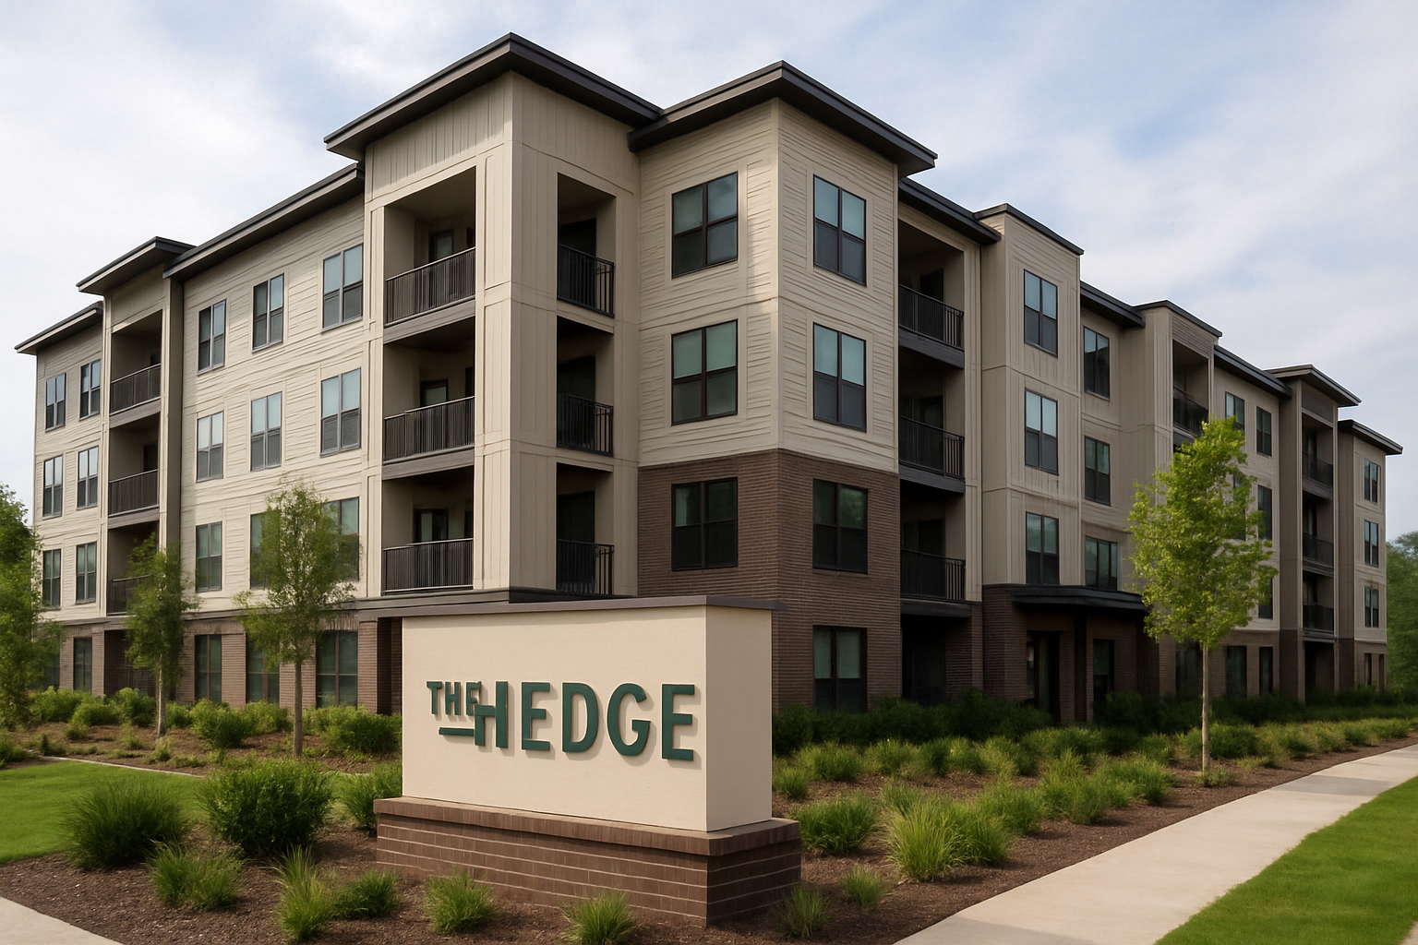

EXHIBIT A

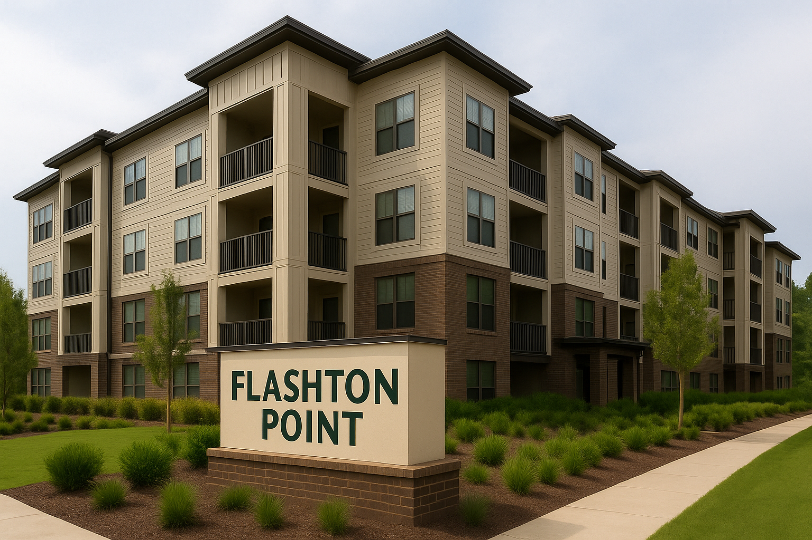

EXHIBIT B

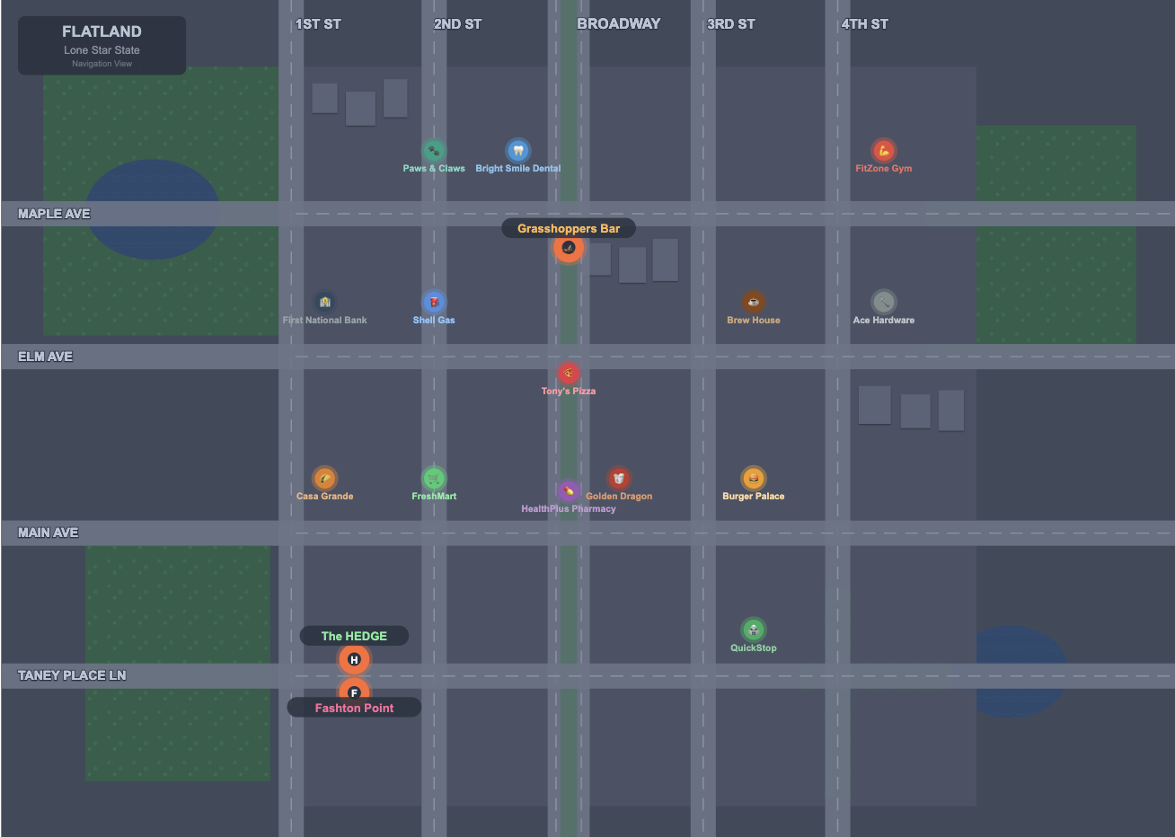

EXHIBIT C

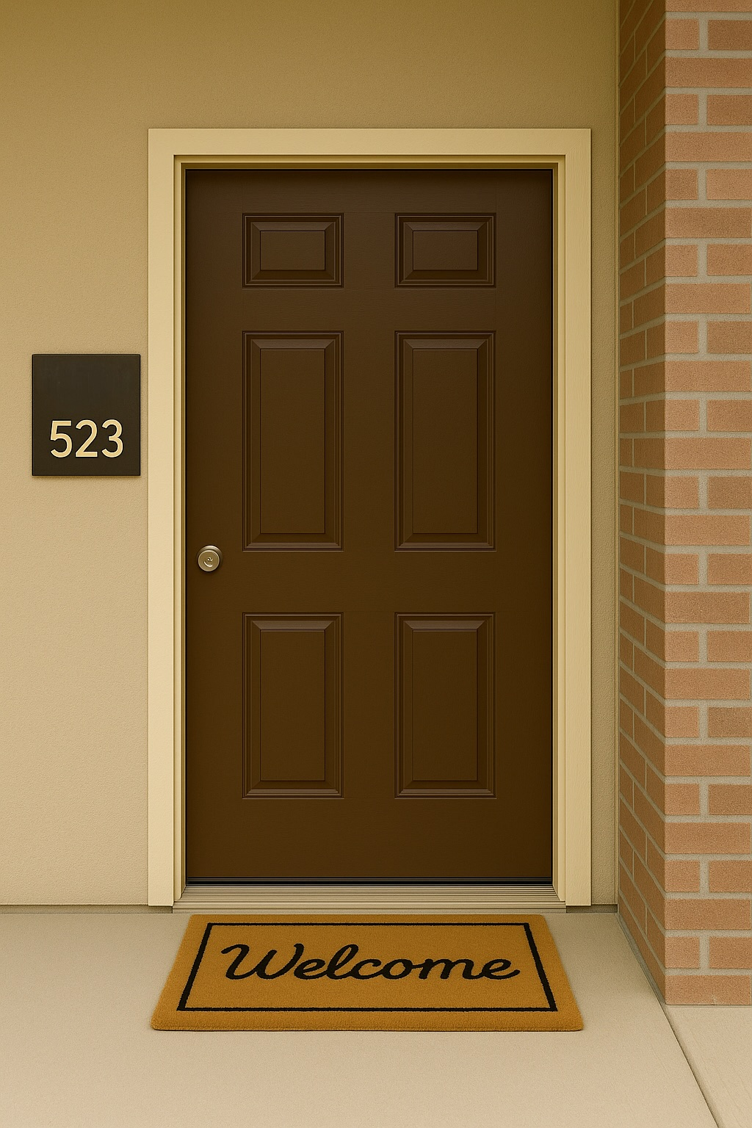
FP

EXHIBIT D

FP

Residential Lease Agreement
Landlord: The HEDGE Apartment Complex (hereinafter “Landlord”)
Management Entity: McFrugual Properties LLC
Tenant (Lessee): Willy Williamson (hereinafter “Tenant”)
Premises: Unit 523, The HEDGE Apartment Complex, 1600 N Taney Place Lane, (Flatland), (Lone Star).
Lease Date: October 1, 2025
Term: 12 months. Lease commences on October 1, 2024 and terminates on September 30, 2025, unless renewed or terminated earlier according to the terms below.

1. Rent
1.1 Monthly Rent: Tenant agrees to pay Landlord rent of $1,650.00 per month, payable in advance on the first day of each month.
1.2 Payment Address: Payments shall be delivered to The McFrugual Properties LLC, at the management office or by electronic payment as directed by Landlord.
1.3 Late Charges: If rent is not received within five (5) days after the due date, Tenant will pay a late charge of $75.00 and interest at 12% per annum on the overdue amount.

2. Security Deposit
2.1 Amount: Tenant shall deposit $1,650.00 as a security deposit to secure performance of Tenant’s obligations.
2.2 Return of Deposit: Subject to deductions for damages, unpaid rent, and other charges permitted by law, deposit will be returned within thirty (30) days of lease termination with an itemized statement of any deductions.

3. Utilities and Services
3.1 Included Utilities: Landlord shall provide water, sewer, and common-area electricity.
3.2 Tenant Responsibility: Tenant shall be responsible for electricity, gas, cable/internet, and telephone services to the Premises unless otherwise agreed in writing.
EXHIBIT E

4. Use, Occupancy, and Conduct
4.1 Use: The Premises shall be used only as a private residence for Tenant and the following permitted occupants: Willy Williamson.
4.2 Occupancy Limit: Maximum of two (2) adult occupants unless approved by Landlord in writing.
4.3 Nuisance: Tenant shall not permit any activity that unreasonably disturbs other residents or violates local ordinances.

5. Pets
5.1 Pet Policy: Pets are allowed only with Landlord’s prior written consent and payment of a non-refundable pet fee of $300.00. Tenant shall be responsible for all pet-related damages and nuisance.

6. Maintenance, Repairs, and Alterations
6.1 Tenant Responsibilities: Keep Premises clean and sanitary; promptly notify Landlord of needed repairs; not permit waste or damage.
6.2 Landlord Responsibilities: Maintain structural components, major systems, and common areas in compliance with law.
6.3 Alterations: Tenant shall not make structural alterations or install fixtures without Landlord’s written consent. Any approved alterations that remain shall become the property of Landlord unless otherwise agreed.

7. Entry by Landlord
7.1 Access: Landlord may enter the Premises in accordance with applicable law for inspection, repairs, or to show the unit to prospective tenants or purchasers. Except in emergencies, Landlord will give Tenant at least 24 hours’ notice where the law requires.

8. Subletting and Assignment
8.1 Restriction: Tenant shall not assign this Lease or sublet the Premises (in whole or part) without Landlord’s prior written consent, which shall not be unreasonably withheld.

9. Default and Remedies
9.1 Default: Failure to pay rent or material breach of lease terms constitutes default.
9.2 Remedies: On default, Landlord may pursue all remedies available at law or in equity, including termination of tenancy and recovery of possession, unpaid rent, damages, and court costs.

10. Insurance
10.1 Tenant Insurance: Tenant is strongly encouraged to maintain renter’s insurance covering personal property and liability. Landlord’s insurance does not cover Tenant’s personal property.

11. Governing Law
11.1 Law: This Lease shall be governed by and construed in accordance with the laws of the State of Lone Star, without regard to conflicts of law principles.

12. Lead-Based Paint Disclosure
If Premises were built before 1978, a federally required lead-based paint disclosure would be attached.

13. Miscellaneous
13.1 Entire Agreement: This Lease, including any attached addenda, constitutes the entire agreement between the parties.
13.2 Severability: If any provision is unenforceable, other provisions remain in full force.
13.3 Notices: All notices shall be in writing and delivered to the addresses of the parties.

14. Move-in Condition / Inventory
Tenant acknowledges receipt of keys and that the Premises were delivered in good and habitable condition except for the following noted defects: Not Applicable.

Signatures
LANDLORD / AUTHORIZED AGENT
Name: ___Hailey Kuykendahl_____________
Title: _______Office Manager______________
Signature: ______ Hailey Kuykendahl ______ Date: _______September 30, 2024_________
TENANT
Name: Willy Williamson
Signature: ____Willy Willaimson_________ Date: _______ September 30, 2024_________

F.G.H. Flatland General Hospital
6738 Onyx Boulevard, Flatland, Lone Star 53623

Discharge Summary

Patient: James Wrigley Date In: 5/17/25

D.O.B.: 12/12/1982 Discharge Date: 5/19/25

James Wrigley, D.O.B. 12/12/1982, was brought to the NGH Emergency Room on May 17, 2025, at 0111 hours. His vital signs were stable, and an examination revealed a single incision on the left side of the patient’s stomach, one inch down and 3 inches away from the belly button. Patient also had minor scrapes on his knuckles.

The patient was sent to surgery at 0345 hours. During surgery, it was confirmed that no vital organs were injured. Patient was stitched up without issue. Patient remained in hospital for further treatment, if necessary, and for monitoring purposes. The patient was discharged on May 19, 2025, and told to seek additional treatment from his personal physician as needed.

Brenden Gilbreath, M.D.

Dictated: May 19, 2025.
EXHIBIT F

F.G.H. Flatland General Hospital
6738 Onyx Boulevard, Flatland, Lone Star 53623

Discharge Summary

Patient: Willy Williamson Date In: 5/17/25

D.O.B.: 2/28/1995 Discharge Date: 5/17/25

Willy Williamson, D.O.B. 2/28/1995, was brought to the NGH Emergency Room on May
17, 2025, at 0147 hours. Patient exhibited no signs of major physical trauma. Patient had
scrapes on the back of the head, but the scrapes had ceased bleeding and had begun to scab over.
Patient had the early signs of a minor hematoma along and above his left eyebrow.

Patient was given Tylenol for any pain, and the patient was discharged on May 17, 2025. No follow-up necessary.

Brenden Gilbreath, M.D.

Dictated: May 19, 2025.
EXHIBIT G

FIC Criminal Record
Name: Willy Williamson

Date of Birth: 2/28/1995

SSN: 001-05-0011

DATE OF ARREST | CHARGE | DISPOSITION
3/16/2013 | Misdemeanor Conversion | 6/21/2013; Guilty Plea  One year conditional discharge
 |  | 6/21/2001; Dismissed
5/19/2023 | Misdemeanor Possession of Marijuana | 5/14/2012; Guilty plea; Fine of $100 plus costs
3/29/2025 | Misdemeanor Conversion | 5/14/2025; Plea of not guilty; ongoing
EXHIBIT H

EXHIBIT I
GRASSHOPPER’S
2801 Off-Broadway Ave,
Flatland, LS 77799

Date: May 17, 2025.

Time: 12:03 a.m.

Server: David Berta

Filler Lite x8 @3.50 28.00

Base Pear x3 @ 4.75 14.25

Jagermeister 06.50

Subtotal 48.75

Tip 16.00

Total 64.75

Pymt Mthd CC VISA
Cardholder WILLY WILLIAMSON
Card No. XXXX-XXXX-XXXX-1234

Willy Williamson
Cardholder Signature

By signing, you agree to pay the full amount listed above.
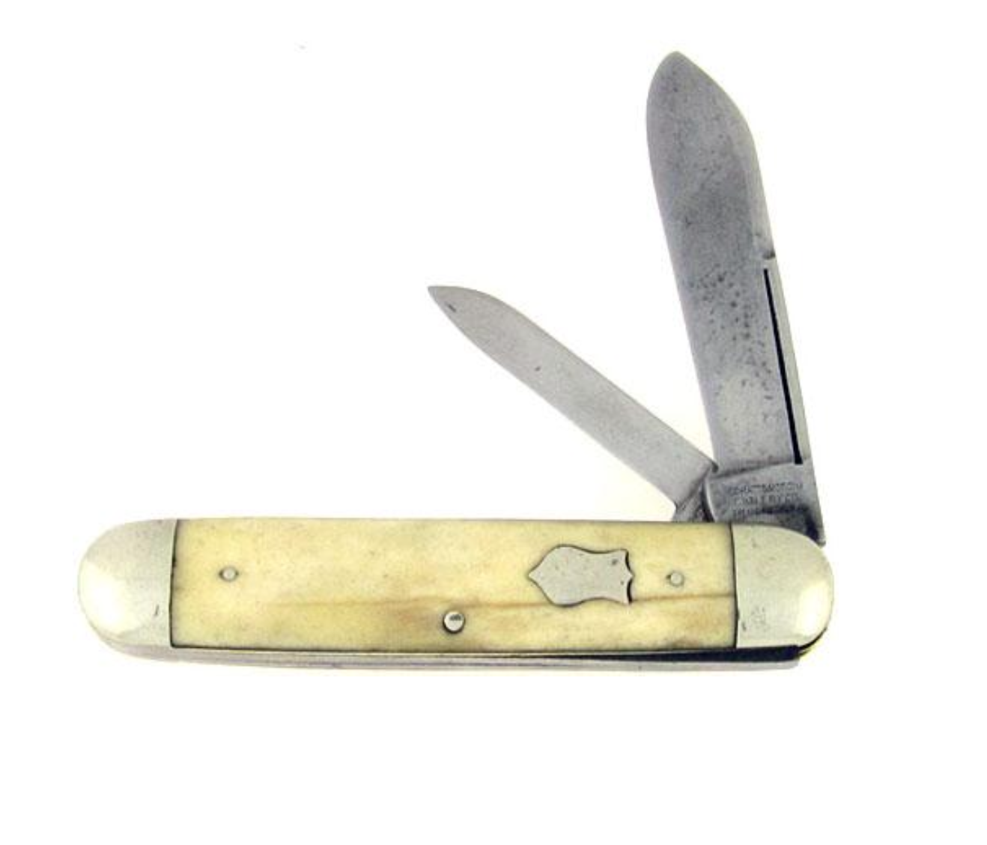
EXHIBIT J

Case No. CR 4219-12
THE STATE OF LONE STAR  vs.  WILLY WILLIAMSON  Defendant, | §  §  §  §  §  §  §  §  § | IN THE DISTRICT COURT  IN AND FOR  ARMADILLO COUNTY, LONE STAR

BUSINESS RECORDS AFFIDAVIT

Before me, the undersigned authority, on this day personally appeared Emely Moreno, who, being duly sworn, deposed as follows:

“My name is Emely Moreno. I am of sound mound, capable of making this affidavit and personally acquainted with the facts herein stated.”

“As custodian of records for Flatland General Hospital, I have attached two pages of records. The records are kept within the regular course of business by Flatland General Hospital, of which an employee or representative, in the regular course of their business made, noted, or otherwise recorded acts, events, conditions, opinions, or diagnoses which are shown herein. The records were made by persons employed by Flatland General Hospital, who had knowledge of the events or incidents and the record was made pursuant to their regular duties and at the time or near the time of the occurrence of the matter recorded. The records which are enclosed are the originals or they are true and correct copies of the original.”

Emely Moreno
Affiant Signature

Subscribed and sworn before me this 29th day of September 2025.

Lauren Berry
Notary Public, in and for the County of Armadillo
APPLICABLE LAW

Lone Star Penal Code § 22.01 – Assault
- A Person commits an offense if the person:
  - Intentionally, knowingly, or recklessly causes bodily injury to another, including the person’s spouse;
  - Intentionally or knowingly threatens another with imminent bodily injury, including the person’s spouse; or
  - Intentionally or knowingly causes physical contact with another when the person knows or should reasonably believe that the other will regard the contact as offensive or provocative.
- An offense under Subsection (1)(a) is a Class A misdemeanor, except that the offense is a felony of the third degree if the offense is committed against:
  - A person the actor knows is a security officer while the officer is performing a duty as a security officer
- For purposes of Subsection (2), the actor is presumed to have known the person assaulted was a security officer if the person was wearing a distinctive uniform or badge indicating the person’s status as a security officer.

Lone Star Penal Code § 22.02 – Aggravated Assault
- A person commits an offense if the person commits assault as defined in § 22.01 and the person:
  - Causes serious bodily injury to another, including the person’s spouse; or
  - Uses or exhibits a deadly weapon during the commission of the assault.

Lone Star Penal Code § 30.05 – Criminal Trespass
- A person commits an offense if the person enters or remains on or in property of another, including residential land, agricultural land, a recreational vehicle park, a building, or an aircraft or other vehicle, without effective consent and the person:
  - Had notice that the entry was forbidden; or
  - Received notice to depart but failed to do so.

Lone Star Penal Code § 9.31 – Self-Defense
- It is an affirmative defense that, except as provided in Subsection (2), a person is justified in using force against another when and to the degree he reasonably believes the force is immediately necessary to protect himself against the other’s use or attempted use of unlawful force.
- The use of force against another is not justified:
  - In response to verbal provocation alone: OR
  - If the actor provoked the other’s use or attempted use of unlawful force, unless:
    - The actor abandons the encounter, or clearly communicates to the other his intent to do so reasonably believing he cannot safely abandon the encounter; and
    - The other nevertheless continues or attempts to use unlawful force against the actor

Lone Star Penal Code § 1.01 – Definitions
      - “Deadly Weapon” means anything that in the manner of its use or intended use is capable of causing death or serious bodily injury.
. . .
(17) “Deadly force” means force that is intended or known by the actor to cause, or in the manner of its use or intended use is capable of causing, death or serious bodily injury.
. . .
(34) “Deadly bodily injury” means bodily injury that creates a substantial risk of death or that causes death, serious permanent disfigurement, or protected loss or impairment of the function of any bodily member or organ.

FINAL JURY INSTRUCTIONS

Members of the Jury, I thank you for your time and attention during this trial. Please pay attention to the instructions I am about to give you.

In this case, Willy Williamson is accused of Criminal Trespass and Aggravated Assault.

Before you can find Willy Williamson guilty of Criminal Trespass, the State must prove the following elements beyond a reasonable doubt:

            - Willy Williamson entered or remained on or in the property of James Wrigley, without effective consent, and Willy Williamson:
              - Had notice that his entry was forbidden; or
              - Received notice to depart but failed to do so.

Before you can find Willy Williamson guilty of Aggravated Assault, the State must prove the following elements beyond a reasonable doubt:

            - Willy Williamson intentionally, knowingly, or recklessly caused bodily injury to James Wrigley; and
              - Caused serious bodily injury to James Wrigley; or
              - Used or exhibited a deadly weapon during the commission of the assault.

A deadly weapon is anything that in the manner of its use or intended use is capable of causing death or serious bodily injury.

The defendant has entered a plea of not guilty. This means you must presume to believe that the defendant is innocent. The presumption stays with the defendant as to each material allegation in the indictment through each stage of the trial until it has been overcome by the evidence to the exclusion of and beyond a reasonable doubt.

The defendant has raised the affirmative defense of Self-Defense. It is the defendant’s burden to prove this affirmative defense by a preponderance of the evidence. Preponderance of the evidence means that the claim is more likely to be true than not true.

The pertinent elements of Self-Defense are as follows:

            - A person is justified in using force against another when and to the degree he reasonably believes the force is immediately necessary to protect himself against the other’s use or attempted use of unlawful force. Except, the use of force against another is not justified:
              - In response to verbal provocation alone; OR
              - If the actor provoked the other’s use or attempted use of unlawful force, unless the actor abandons the encounter, or clearly communicates to the other his intent to do so reasonably believing he cannot safely abandon the encounter; and the other nevertheless continues or attempts to use unlawful force against the actor.

Therefore, even if you find beyond a reasonable doubt that the defendant, Willy Williamson, did commit aggravated assault, but you further find by a preponderance of the evidence that the defendant was justified in using force against James Wrigley when and to the degree he reasonably believed the force was immediately necessary to protect himself against James Wrigley’s use or attempted use of unlawful force, you will find the defendant not guilty of aggravated assault.

If you find that the defendant was not justified in using force against James Wrigley as defined above, then you must find the defendant guilty of aggravated assault.

The defendant is not required to prove anything other than any affirmative defenses he has raised.

Whenever the words “reasonable doubt” are used, you must consider the following:

A reasonable doubt is not a possible doubt, a speculative, imaginary, or forced doubt. Such a doubt must not influence you to return a verdict of not guilty if you have an abiding conviction of guilt. On the other hand, if after carefully considering, comparing and weighing all the evidence, there is not an abiding conviction of guilt, or, if having a conviction, it is one which is not stable but one which wavers and vacillates, then the charge is not proved beyond every reasonable doubt and you must find the defendant not guilty because the doubt is reasonable.

It is to the evidence introduced upon this trial, and to it alone, that you are to look for that proof.

A reasonable doubt as to the guilt of the defendant may arise from the evidence, conflict in the evidence, or the lack of evidence.

If you have a reasonable doubt, you should find the defendant not guilty. If you have no reasonable doubt, you should find the defendant guilty.

It is up to you to decide what evidence is reliable and to what degree. You should use your common sense in deciding which is the best evidence, and which evidence should not be relied upon in considering your verdict.

There are some general rules that apply to your discussion. You must follow these rules in order to return a lawful verdict:

            - You must follow the law as it is set out in these instructions. If you fail to follow the law, your verdict will be a miscarriage of justice. There is no reason for failing to follow the law in this case. All of us are depending on you to make a wise and legal decision in this matter.
            - This case must be decided only upon the evidence that you have heard from the answers of the witnesses and have seen in the form of the exhibits in evidence and these instructions.
            - This case must not be decided for or against anyone because you feel sorry for anyone or are angry at anyone.
            - Remember, the lawyers are not on trial. Your feelings about them should not influence your decision in this case.
            - Your duty is to determine if the defendant is guilty or not guilty, in accord with the law. It is the judge’s job to determine what a proper sentence would be if the defendant is guilty.
            - Whatever verdict you render must unanimous; that is, each juror must agree to the same verdict.
            - It is entirely proper for a lawyer to talk to a witness about what testimony the witness would give if called to the courtroom. The witness should not be discredited for talking to a lawyer about his testimony.
            - Feelings of prejudice, bias, or sympathy are not legally reasonable doubts, and they should not be discussed by any of you in any way. Your verdict must be based on your views of the evidence and on the law contained in these instructions.
Deciding a proper verdict is exclusively your job. I cannot participate in that decision in any way. Please disregard anything I may have said or done that made you think I preferred one verdict over another.
Only one verdict may be returned as to the crimes charged. This verdict must be unanimous; that is, all of you must agree to the same verdict. The verdict must be in writing, and, for your convenience, the necessary forms of verdict have been prepared for you. They are as follows (read verdict forms).
In closing, let me remind you that it is important that you follow the law spelled out in these instructions in deciding verdicts. There are no other laws that apply to this case. Even if you do not like the laws that must be applied, you must use them. For two centuries we have agreed to a constitution and to live by the law. No one of us has the right to violate rules we all share.

Case No. CR 4219-12
THE STATE OF LONE STAR  vs.  WILLY WILLIAMSON  Defendant, | §  §  §  §  §  §  §  §  § | IN THE DISTRICT COURT  IN AND FOR  ARMADILLO COUNTY, LONE STAR

We, the Jury, find as to the Defendant, Willy Williamson, as follows:
As to Count 1 – Criminal Trespass
Guilty of Criminal Trespass

Not Guilty

As to County II – Aggravated Assault
Guilty of Aggravated Assault

Not Guilty

So say we all,

Foreperson of the Jury

Date

