No. CR-04-9182
HARRY POTTER § IN THE DISTRICT
Plaintiff, § COURT
§
§
§
§ IN AND FOR
v. §
§
§
§
SEVERUS SNAPE § HOGSMEADE COUNTY,
Defendant. § LONESTAR

Prepared by
Conner Haugen
&
Kalle Riner
Texas Tech University School of Law ’20
3311 18th Street
Lubbock, TX 79409

Copyright 2019
All Rights Reserved

This case file was commissioned by the Texas Tech Board of Barristers for the
Fall 2025 Advanced Mock Trial Competition.
Statement of the Case

This is a wrongful death action brought by Harry Potter on behalf of Albus Dumbledore against Severus Snape for the murder of Albus Dumbledore. Harry Potter is the last living heir of Albus Dumbledore and stands to inherit his estate.

Hermione Granger is a private investigator and a forensic detective. She went to the academy for the FBI and spent 17 years as the lead forensic detective for the felony division. She then retired and opened a small private investigator office. Granger prides herself in being trained at the Beauxbaton Toxicologist Academy. On the night of the murder of Albus Dumbledore, Hermione received a call from Mr. Olivander. This call prompted a thorough investigation into the mysterious death of Albus Dumbledore. In her deposition, she testified that the body of Albus Dumbledore was found washed up on the “Ocean Beach” of South Lonestar on July 2, 2025. She stated that analysis of the scene included an unidentified amount of cyanide, a dangerous chemical that causes a horrible death when ingested. Notably, the body had been covered in bleach before being found under the pier. More importantly, a ripped piece of black cloth found at a nearby lifeguard tower revealed the DNA of Severus Snape.

Dobby Elfree is the police chief of Lonestar. He testified that he has never trusted Snape. Elfree states in his deposition that he investigated the home of Snape prior to the criminal trial against Snape. Snape was not found to have committed the murder beyond a reasonable doubt. Upon a complete search of Severus Snape’s home, Elfree found five empty bottles of bleach hidden under the basement sink. Elfree testified that this is not the first time Snape has been involved in an investigation related to a murder. The police chief additionally smelt a strong chemical odor emanating from the underground basement, where the laundry is kept. The deposition states that Snape had been investigated by the Lonestar Police for the murder of Peter Petigrew—a man that died via ammonia-sulfide ingestion, and he was covered in a bleach-substitute. Petigrew’s body was found on North Beach two years ago.

During Severus Snape’s deposition, Snape testified that he was helping a friend move on the night of the murder from Lonestar to Lontana, a nearby state. While the friend is unavailable to testify, Snape claims his alibi holds true through picture evidence of him entering a gas station 95 miles away around the estimated time of the murder. Snape did admit to being at Ocean Beach prior to helping his friend move to Lontana, but only to partake in his favorite pastime, surfing. Additionally, Snape stated that Dumbledore was his friend, and Snape would never hurt him.

Ginny Weasley took an interest in this case and offered her investigative efforts in order to qualm any thought that Snape killed Dumbledore. Weasley testifies that not only does she have multiple PhDs, in the fields of forensics, body examination, and chemistry, but she also was recently named the best lab scientist in Diagon Alley magazine for the third year in a row. Weasley testifies that there is simply not enough evidence to make a conviction, especially a conviction of a man who had bleach bottles in his cabinet. Additionally, the black cloth found near the scene is contaminated from the men and women at the beach that night. Weasley states in his deposition that at best there is circumstantial evidence and not enough to justify a reward for Potter.

STIPULATIONS REGARDING EVIDENTIARY MATTERS

Procedural Matters
- Federal Rules of Civil Procedure and Federal Rules of Evidence apply.
- This case shall be tried on liability only. Should the plaintiff prevail on liability, the question of damages shall be heard by the jury with additional evidence and additional jury instructions at a later date.
- All witnesses called to testify who have previously identified the parties, other individuals, or tangible evidence in their respective depositions can, if asked, identify the same at trial.
- Each witness who gave a deposition agreed, under oath, at the outset of his/her deposition to give a full and complete description of what occurred and to correct the deposition for inaccuracies and completeness before signing the deposition.
- All depositions were signed under oath.
- For the purposes of this competition, no team is permitted to impeach a witness by arguing to the jury that a signature appearing on the deposition does not comport with signatures or initials located on an exhibit.
- Other than what is supplied in the problem itself, there is nothing exceptional or unusual about the background information of any of the witnesses that would bolster or detract from their credibility.
- This competition does not permit a listed witness, while testifying, to “invent” an individual not mentioned in this problem and have testimony or evidence offered to the court or jury from that “invented” individual.
- Each party must call the two witnesses listed as that party’s witnesses on the witness list.
- The four witness roles are not intended to be gender-specific; i.e., a male may play Hermione Granger for a round despite her female gender in the problem. By the same token, teams should make considerable efforts to adapt to the witnesses in each round and refer to their appropriate genders.
- All exhibits in the file are authentic. In addition, each exhibit contained in the file is the original of that document unless otherwise noted on the exhibit or as established by the evidence.
Substantive Matters
- Lonestar Civil Practice and Remedies Code 71.002:
Wrongful Death: A person is liable for damages arising from an injury that causes an individual's death if the injury was caused by the person's wrongful act, neglect, carelessness, unskillfulness, or default.
- The parties stipulate that cyanide was the cause of Albus Dumbledore’s death.
- The autopsy report marked as Exhibit 9 is an official public record.
- If asked, Hermione Granger is able to make an in-court identification of Severus Snape as the person the police arrested.
- The gas station clerk on duty the night in question, Mr. Clark K, was previously deposed. Mr. K provided the original receipt, Exhibit 3. Additionally, Mr. K testified as to the gas station surveillance footage that Exhibit 4 was pulled from. Mr. K is unavailable for trial, so Exhibits 3 & 4 have been pre-admitted and are in evidence.
- Myrtle Elizabeth Warren and Raven Diadem are unavailable as a witness, as defined in the Federal Rules of Evidence, and shall be treated as such.
- Parties should not question the numerical figures listed in the chart in Exhibit 7.

WITNESS & EXHIBIT LIST

Witnesses for the Plaintiff:
- Hermione Granger
- Dobby Elfree
Witnesses for the Defendant:
- Severus Snape
- Ginny Weasley
Exhibits

- Black Cloth
- Photo of Deceased
- Receipt from Gas Station
- Gas Station Photo
- Text Messages from Raven Diadem
- Hermione Granger DNA Analysis
- Ginny Weasley DNA Analysis
- Analysis of Bleach at Scene
- Autopsy Report
- Indictment, Cedric
- Indictment, Neville
- Escape Report
- Laboratory Employee Salaries
- Physical Bleach Bottle
No. CR-04-9182
HARRY POTTER § IN THE DISTRICT
Plaintiff, § COURT
§
§
§
§ IN AND FOR
v. §
§
§
§
SEVERUS SNAPE § HOGSMEADE COUNTY,
Defendant. § LONESTAR

PLAINTIFF’S ORIGINAL COMPLAINT

TO THE HONORABLE COURT:

COMES NOW, Plaintiff Harry Potter, individually filing this original Complaint against Severus Snape.
I.
General Allegations
- This is an action for damages within the jurisdictional limits of this Court.
- Harry Potter has been a resident of Hogsmeade county since 2001.
- Albus Dumbledore was a resident of Hogsmeade country from 1987 until the date of his death on July 2, 2025.
- The intentional wrongful death that is the subject of Plaintiff’s Original Complaint occurred in Hogsmeade County, State of Lonestar.
- On July 2, 2025, Mr. Dumbledore’s body was found under the pier of Ocean Beach.
- Mr. Dumbledore died as a result of dangerous chemical ingestion.
- Harry Potter is Mr. Dumbledore’s only living relative.
- Harry Potter has been duly appointed administrator of Albus Dumbledore’s estate.
II.
COUNT 1 – WRONGFUL DEATH
- Plaintiff incorporates by reference the allegations of paragraphs 1 through 9 as if fully restated herein.
- On July 2, 2025, Albus Dumbledore was found under the pier on Ocean Beach with traces of a deadly toxin and bleach.
- A piece of black cloth near the scene was found containing the DNA of the Defendant.
- Upon a lawful search of the Defendant’s home, bleach containers found under the Defendant’s basement sink were the exact brand of bleach used in the murder.
- Defendant intentionally forced Mr. Dumbledore to ingest a toxic chemical in efforts to become the new Dean of the Chemistry department.
- As a direct result of Defendant’s intentional actions, and the death of decedent Albus Dumbledore, Plaintiff Harry Potter has sustained non-economic damages consisting of mental or emotional pain or anguish, loss of companionship and society, inconvenience, loss of enjoyment of life, and all other nonpecuniary losses of any kind other than exemplary damages.
III.
JURY DEMAND
- Plaintiff hereby requests a trial by jury.
IV.
PRAYER FOR RELIEF
WHEREFORE, Plaintiff, individually requests that the Defendant be cited to answer and appear, and that upon final hearing the Plaintiff have judgement for damages, exemplary damages, pre-judgment and post-judgment interest as allowed by law, costs of suit and such other and further relief, at law or in equity, to which Plaintiff may be justly entitled.
Respectfully Submitted,

Law Offices of Dakota J. Mason
2205 Finnigan Rd.
Hogsmeade, Lonestar 73859

By: _______________________
Dakota J. Mason
State Bar No. 00058295

No. CR-04-9182
HARRY POTTER § IN THE DISTRICT
Plaintiff, § COURT
§
§
§
§ IN AND FOR
v. §
§
§
§
SEVERUS SNAPE § HOGSMEADE COUNTY,
Defendant. § LONESTAR

DEFENDANT’S ORIGINAL ANSWER

TO THE HONORABLE COURT:

COMES NOW SEVERUS SNAPE by and through its undersigned counsel and files Defendant’s Original Answer.

I.
Answer
- Defendant admits the allegations in Paragraph 1 for jurisdictional purposes only.
- Defendant is without sufficient knowledge to admit or deny the allegations in Paragraph 2 and therefore denies the same.
- Defendant admits the Albus Dumbledore died on July 2, 2025. Defendant is without sufficient knowledge of the remaining allegations in Paragraph 3 and therefore denies the same.
- Defendant denies the allegations in Paragraph 4 to the extent Dumbledore’s death is categorized as an intentional, wrongful death. Defendant admits that Dumbledore passed away in Hogsmeade County, State of Lonestar.
- Defendant admits the allegations in Paragraph 5.
- Defendant is without sufficient knowledge to admit or deny the allegations in Paragraph 6 and therefore denies the same.
- Defendant is without sufficient knowledge to admit or deny the allegations in Paragraph 7 and therefore denies the same.
- Defendant is without sufficient knowledge to admit or deny the allegations in Paragraph 8 and therefore denies the same.
- Defendant realleges its answers to Paragraphs 1 through 8 as if fully set forth herein.
- Defendant admits the allegations in Paragraph 10.
- Defendant admits the allegations in Paragraph 11.
- Defendant denies the allegations in Paragraph 12.
- Defendant denies the allegations in Paragraph 13.
- Defendant denies the allegations in Paragraph 14.
- Defendant requests a trial by jury, and as such, admits the allegations in
Paragraph 15.
II.
Affirmative Defenses

- Without waiver of the foregoing but in addition thereto, Defendant affirmatively pleads that the death of Albus Dumbledore in Plaintiff’s Original Complaint was caused by an unidentified criminal.
- Defendant has photo evidence of himself entering a gas station on the night of the incident and that this location was 95 miles from the scene.
- Accordingly, Plaintiff may not recover any damages from the Defendant for the death of Albus Dumbledore or for any previous or future allegation.
III.
Prayer
WHEREFORE, Defendant requests that, upon final trial, that Defendant have judgment that Plaintiff take nothing by its suit, that Defendant be discharged from any and all liability, that Defendant recover court costs and for such other and further relief, at law or in equity, general or special, to which Defendant may show itself justly entitled.
Respectfully Submitted,

Heather R. George
6629 Dolohov Blvd.
Hogsmeade, Lonestar 73856

By: ___________________
Heather R. George
State Bar No. 00038275

CERTIFICATE OF SERVICE
I hereby certify that a true and correct copy of Defendant’s Original Answer has been served by U.S. Mail to Dakota J. Mason, Finnigan Rd., Hogsmeade, Lonestar, 73859 on this day July 18, 2025.
By: ____________________
Heather R. George

Deposition of Hermione Granger
Q: Please state your name for the record.
A: Hermione Granger.
Q: What do you do for a living?
A: I am a currently a private investigator but most of my work centers around toxicology and its effects.
Q: Are you trained in this type of work?
A: Yes, I am.
Q: How long have you been in this field?
A: Well, I worked as the lead FBI forensic detective for 17 years before I opened my own private investigation office. I have now been running that office for 6 years where most of my work consists of forensic and DNA analysis.
Q: What kind of coursework did you engage in?
A: I was trained in forensic analysis. Particularly, I focused my training in DNA analysis, toxicology, and trace evidence. At the Beauxbaton Toxicology Academy, hopeful mentees worked long 12-hour days, seven days a week. The hours were long, but it was a big pay-off if you finally make it to the most prestigious team of toxicologists in the world.
Q: How many accidents have you investigated in your career?
A: During my 23 years of experience I have investigated 182 crime scenes. Of those 182 scenes, 32 involved dangerous chemicals.
Q: I’m sure you have some achievements you are proud of?
A: Oh yes. I am very proud of the distinctions I have earned because of my hard work. I was designated as the “Best Forensic Investigator in the State of Lonestar” for the past 3 years by Quibbler Magazine, the most renown scientific magazine available today.
Q: Ms. Granger, did you investigate an accident that occurred on July 2, 2025, located under the Ocean Beach pier?
A: Yes. It was unfortunate. Even after all of these years I still do not enjoy seeing the horror that people are capable of.
Q: How did you learn about the accident?
A: I received a call from Mr. Olivander. He was taking his nightly stroll on the beach and came across a body laying underneath the pier of Ocean Beach. He told me he was shocked and that the man was dead. The paramedics were called soon after that. Because of the call, I rushed down to the beach to begin a preliminary investigation.
Q: When did you first arrive at the scene?
A: I got to the scene as quick as I possibly could. It was approximately 2:34 a.m. when I arrived because I had encountered a surprising amount of traffic on the way there. Normally there are not people on the road at that hour of the night.
Q: Did you notice anything unusual?
A: Yes, there was this overwhelming stench coming from the body. In particular, the body smelled of heavy chemicals. It felt like my nostrils were burning. I already knew that whoever it was died a horrible death. I photographed the body at this time.
Q: Why do you think that there was foul play involved?
A: Because of these chemicals. It smelled like pure bleach, with something even stronger emanating from the body. In my experience, when a person dies from normal causes, they are not covered in a large amount of heavy chemicals. Nor are they found on the beach under a pier.
Q: Did you find out what chemicals were on the body?
A: Yes, I found an abundance of bleach spread all over the body. Bleach was spread on the body to cover DNA traces from the culprit. That is the only reasonable explanation of why bleach would be on the body in such a high quantity. But that was not even the worst part—a further analysis of the body revealed the other chemical was cyanide.
Q: What effects do these chemicals have?
A: Bleach can cause death when ingested, but if treated quickly enough, it can be reversible. Cyanide, however, is one of the worst chemicals out there. It can absolutely—and very easily—kill a person.
Q: Are you familiar with the specific effects of cyanide?
A: Yes, it is one of the poisons we studied during school. The skin of the victim is often weirdly cherry-red or an odd-looking pink after the chemical is ingested. This happens because oxygen stays in the blood and does not actually get to the cells. If found alive, the victim is often found short of breath and confused. The skin of Mr. Dumbledore’s body was not normal when I found him. That is one of the reasons why I was called to the scene. The police thought there was foul play involved and thought chemicals were the cause.
Q: Did cyanide cause the death in this case?
A: There is no doubt that Albus Dumbledore died due to the ingestion of cyanide. After receiving the autopsy report from the coroner, it was evident the chemical ran into the mouth, down the esophagus, and landed in the stomach. Cyanide killed Dumbledore from the inside-out. Whoever did this deserves to be put in jail for the rest of their life.
Q: What was the next thing you did after you noticed the chemicals at the scene?
A: I walked around the scene to see if there was any additional evidence that could be useful in apprehending the suspect.
Q: Did you find anything?
A: Yes, I did. I found a small piece of black cloth. It kind of looked like it came from a wet suit. I photographed the cloth before collecting it.
Q: Was there analysis performed on the cloth?
A: Once back at my lab, I ran an analysis on the cloth.
Q: What were the results of that analysis?
A: There was DNA from three different men on the cloth. Two of the “DNA donators” were unidentified males and the other popped up in our system as a Severus Snape.
Q: Were you able to pull any DNA other than the DNA of the deceased off of the body or his clothes?
A: The bleach absolutely ruined any chance at getting DNA from the deceased. We tried the best we could but did not come up with any hits.
Q: Could you tell if the deceased fought back or resisted?
A: Yes, it was obvious there was a fight. His fingernails were messed up and he had scratches all over him as if there was a struggle. But…the bleach ruined any DNA evidence we could have found. All that I found on the body was a single strand of dark brown hair approximately 3 inches long.
Q: Did you speak with anyone at the scene?
A: I spoke originally with Olivander, as I knew he was shaken up by the situation.
Q: Did you ask Olivander if he knew Dumbledore?
A: Actually, I did. It turns out Olivander and Dumbledore had been friends since they were much younger. I am pretty sure he said they worked together on some big chemistry project in the past. I cannot imagine how hard it must have been for Olivander, Dumbledore’s friend, to have found him lying there under the pier.
Q: What else did Olivander tell you about Dumbledore?
A: He told me that every Monday and Thursday for the past 5 years they walk the beach together in middle of the night to look at the stars. Olivander thought it was odd that Dumbledore did not answer his phone call that night to have their weekly walk, but he shook it off as no big deal.
Q: Based on your investigation, were you able to determine a time of death?
A: The time of death was right before we got there—according to the coroner’s report. Mr. Dumbledore died no earlier than 1:30 a.m.
Q: What did you base that on?
A: The coroner’s office always bases this off of the color of the body at the time it was found, the stage of rigor mortis, and the temperature of the body. All of these signs pointed to a death within an hour or so of me prior to me arriving on scene. I am extremely familiar with time of death analysis because of my extensive experience as the lead forensic investigator.
Q: Did you fill out a formal report?
A: I did.
Q: Does your report have anything pertaining to time of death?
A: I have that information in my report.
Q: Does time of death have much significance in a case like this?
A: It certainly can have significance. Specifically, in cases where the police department are trying to place a culprit at the scene, it can narrow the possible suspects based on their alibis.
Q: Is there anything else you would like to say?
A: I have known Snape for a long time, actually since grade school, and he is a person I would never want to cross.
Q: Why is that?
A: It is known all around town that Snape and Dumbledore have “beef.” To be honest, it does not surprise me that his DNA showed up on the black cloth.

Deposition of Dobby Elfree
Q: Can you please state your name for the record?
A: My name is Dobby Elfree.
Q: What do you do Mr. Elfree?
A: I am the police chief in Hogsmeade. It is my job to ensure that the city is protected from criminals. I take my job very seriously as many days it is a life or death situation.
Q: How long have you been police chief of Hogsmeade?
A: I am kind of new at this job. I have only been the police chief for the past 6 months. However, I have been in the field of policing since 1991. 15 years of that time was spent on the SWAT unit. I am proud to have been elected the chief in this past year.
Q: Can you tell me how you found out about the death of Albus Dumbledore?
A: I heard about the case the morning after the death occurred. I would have been at the scene that night, but I did not receive a call from the officers on duty. However, they did report all pertinent details to me, and our office took the case very seriously.
Q: What actions were taken by the police station?
A: A forensic analysis of the scene was the first step in our investigation. Once we received information that Severus Snape’s DNA was found on the black cloth near the scene, we applied to the county judge for a warrant to search Snape’s house. We were hesitant to do so at first, but once we saw that there was bleach on the ripped piece of wetsuit, we had to make an effort to enter his house.
Q: Was Snape your sole lead at this point?
A: Snape was the only lead as the person who murdered Albus Dumbledore. His DNA was found on a torn piece of wetsuit. That piece of wetsuit was hanging from a nail on a lifeguard tower. It was kind of like he was in a rush to get off the beach and tore it by accident. I guess a good reason to rush off the beach is if you just killed someone.
Q: What else tied Snape to the scene?
A: Well this is not conclusive, but we did find a strand of hair on the body of Dumbledore. The strand was the same color as Snape’s hair.
Q: How do you know that it was the same color?
A: I am sure of it. I searched his house after we obtained a lawful warrant and he was there. I saw him with his medium length dark brown hair.
Q: Can you tell me what happened after you got the warrant?
A: Myself and three of my officers searched his house from top to bottom. The place was pretty much spotless in terms of evidence except for the smell coming from the basement and the bleach bottles that we found.
Q: Did that smell prompt you to investigate the basement?
A: Oh yeah. Because it was the kind of smell that kind of burns your nose. It just smelled like heavy chemicals. The smell emanated strongest next to the laundry. I imagine clothes or something had a heavy chemical on them and were washed right there.
Q: Were you able to confirm that there were heavy chemicals, such as cyanide, in the house?
A: Well, we did not find any. It did not make any sense though. I have a hunch that it had been removed right before we got there.
Q: You mentioned you found bleach bottles; can you tell me more about that?
A: I physically saw the bleach bottles underneath the sink in his basement. They were hidden behind a bunch of surfboard wax or something like that. I paid special attention to this because both the bleach used in the murder and the bleach found under the sink were the same exact brand. The brand is called TT’s Low-Cost Bleach. It’s just odd to have that much bleach laying around the house.
Q: How do you know that the bleach used at the crime scene and the bleach under the sink were the same?
A: I had my forensics department conduct an analysis of the bleach found at the scene. TT’s Low-Cost Bleach has a special additive that is specific only to that brand.
Q: Did you speak to anyone while you were conducting the search of the home?
A: Only to my officers. Snape stayed out of our way and did not say a word. It was like he did not even care we were there. He was probably just used to it; he’s been suspected of a similar crime before.
Q: Can you tell me more about that?
A: It was about 4 years ago when an eerily similar murder occurred at the other beach in our town, North Beach. Peter Pettigrew, age 78, was found covered in a bleach-substitute and died from chemical ingestion. Snape was connected to the crime, so we were able to get a warrant to search his house.
Q: How was Snape connected to the crime?
A: Well, being that Snape works in the chemistry building, he naturally has access to lots of chemicals. In that laboratory, the chemical used to kill Mr. Pettigrew was missing from their stores. Can you guess who the last person was to log entry to the laboratory—Severus Snape.
Q: Was Snape tried for that crime too?
A: He was but the jury ultimately acquitted him. It’s a shame because it’s obvious there is a murderer in our town who gets his jollies off by killing innocent civilians with chemicals.
Q: Was Snape tried for the murder of Albus Dumbledore?
A: He was. Once again, the jury let a murderer get away. I’ve never trusted Snape. The whole town knows that he’s always been after Albus Dumbledore’s job. It is no secret that Snape needs the money.
Q: How do you know that Snape needs money?
A: When I came up to his house with the warrant, I noticed there was a foreclosure sign on his front door. Lab technicians do not make very much money. It seems that Snape was trying to live beyond his means.
Q: Are you sure that Mr. Dumbledore earned more money than Snape?
A: I am certain. The salary of any person who works at Ilvermorny University is public knowledge. All you must do is search on a web browser and you can find it. Snape was always a prodigy at his craft but did not make as much as he would like. He makes about $64,000 per year while his superior, Dumbledore, made over a quarter of a million dollars.
Deposition of Severus Snape
Q: Can you please state your name for the record?
A: My name is Severus Snape.
Q: Do you understand why we are here?
A: To some extent I understand, but I am really hurt by the fact that Mr. Potter thinks I could have committed this horrible crime. I may not come across as the friendliest guy, but I would never do anything like this.
Q: Let’s take a step back, what do you do Mr. Snape?
A: I am a lab technician for Ilvermorny University. Most of my day consists of doing experiments on how to clean the oceans. It is a favorite past-time of mine because I love surfing, and I love the earth we live on.
Q: How long have you been working as a lab technician at Ilvermorny University?
A: It has been quite some time now. I started when I was just a boy, cleaning the bathrooms and doing anything I could to be in the presence of the most renown scientists in the world. As a career though, I have been working as a lab technician for the past 6 years. It has been an honor, and I look forward to building my career even further.
Q: Can you tell me where you were on the night of July 1, 2025?
A: Most of the night I was helping one of my dear friends, Raven Diadem, move apartments. I have known her since elementary school. We go way back.
Q: Around what time was that?
A: I started helping her sometime around 9:30 p.m. She had texted me asking when I was going to arrive. Those texts might better be able to tell you when I left.
Q: Can you tell me, in chronological order, what happened from 9:30 p.m.—on?
A: Of course. So initially, I got into my car and started to drive to the nearby state of Lontana. That is where Raven lives. On the way there I had to get gas and really needed some coffee because I was tired. I stopped at a gas station about 95 miles from Lontana, and I got myself a cup of coffee. I paid the lady at the register and then went to my car to finish pumping the gas. I still have the receipt for the coffee, luckily. It has a time stamp and everything. After that, I pulled up to Raven’s apartment around 11:00 p.m.
Q: Why were you helping her move at such a late hour?
A: Raven told me that she was going to be working all day and it was better to move at night because it’s not as hot. Raven works in the military department out at the government building. She often has long days at work and I’m the type to always lend a helping hand to a friend. Plus, it doesn’t hurt that we used to be involved.
Q: Involved?
A: Well, you know, like we used to date. Let’s leave it at that.
Q: How long did it take to help Raven?
A: Oh, it was probably an hour or so.
Q: Did you do anything else after helping her move?
A: Nope. I was exhausted so I just drove back home and went to bed.
Q: Did you talk to or see anyone on your way home?
A: The only person I talked to was my dog, Fang. I know it is silly, but he is pretty much my only friend. Sometimes I even sing to him at night. His favorite song is, “Eye of the Hippogriff” by the Weird Sisters. Singing keeps my loneliness at bay.
Q: Are you often lonely?
A: Yes. The people at work do not really like me because I am a quiet person. It is just hard to fit in sometimes. But that is okay because I have Fang. He keeps me company and makes sure that I don’t go too crazy when I’m home alone all day.
Q: What did you do earlier in the day on July 1, 2025?
A: I was able to relax most of the day. I finished all my work at the lab around noon and went out for an enjoyable day on the waves. Surfing is a big part of my life, and I make sure that I have time for it every week. I think I ended up surfing until to the sun went down around 8 p.m. It was amazing. Except for the fact that I could not find my surfboard wax. I am not sure where it went.
Q: Why do you need surfboard wax?
A: It helps the board glide over the water as gently as possible. You can ride waves easier when you have it.
Q: Do you wear a wetsuit when you go surfing?
A: Not usually, but I did on July 1st. It was just too cold to go without it.
Q: Was your wetsuit fully intact when you got home?
A: It was not. It must have ripped on my board when I wiped out or something. It looked like there was a chunk of fabric pulled out from it. My guess is that it happened on the coral reef. Surfers have been messed up pretty bad on that reef before. I normally try to stay away from the reef because its only on the left side of the pier but it’s possible I scraped up against it when I wiped out.
Q: Let’s change gears just a bit. Why would there be bleach on your wetsuit?
A: It’s possible that bleach was found because I had a massive project to do in my house. My neighbor’s son spilled paint on their brand new faux polar bear fur rug. I was just trying to do them a favor and get it off. I would be willing to bet that bleach spread to a lot of my things. I wish I would have been more careful. Bleach is a tough substance and can ruin clothes.
Q: How was your relationship with Dumbledore?
A: Dumbledore was a rigid man in the workplace. He required a lot of his employees and that caused tension. That does not mean I would kill him. I just didn’t want him to be my boss. But I kept my head down because hard workers get promoted and that’s all I ever wanted. To be included among the best scientists in the world.
Q: Do you know anything about a foreclosure on your house?
A: Yes, unfortunately, times have been hard lately, and I have made some bad investments. I have not been able to pay my mortgage because of some family issues, but hopefully I can catch up soon. I just want to focus on my job and get to the life I always dreamed of.
Q: Now that Dumbledore has passed away, do you know who will be promoted to the top of the Chemistry department?
A: I have no idea. Hopefully someone qualified because that job is very difficult. The pay is better, but the hours are much longer.
Q: Are you interested in becoming the Dean of the Chemistry Department?
A: Whoever gets that job will have to make some serious sacrifices, and I just don’t know if I could cut down on my surfing. Being on the water fills me with joy and my work-life does not. However, if I was offered the job, I would seriously consider it. The pay is just too tempting, and I am in a rough spot.
Deposition of Ginny Weasley
Q: Can you please state your name for the record?
A: Ginny Weasley.
Q: Do you know why we are here today?
A: I do. I am here to testify about the death of Albus Dumbledore. I have been asked to share my knowledge of forensics and apply it to this case.
Q: What qualifications do you have to testify on such a matter?
A: I hold 2 PhDs. I obtained them while I was living overseas in Japan. One is in forensics with a focus on DNA analysis and the other is in descriptive toxicology with a focus on organism reactions.
Q: How long have you been working in the forensics field?
A: I was in school for approximately 11 years to obtain both of my degrees, but since then, I have been working in Star-Tech Labs for over 22 years. Most of my time here has been focused on pulling and analyzing trace DNA from objects. It is important work because if done correctly it can reveal other potential culprits.
Q: Have you received any awards in your field?
A: Yes. I was named the best lab scientist in Diagon Alley Magazine, the most renowned scientific publication in all of Lonestar, for the past three years. Additionally, I graduated at the top of my class with honorary distinctions.
Q: What was the extent of your involvement with this case?
A: I was contacted by the attorney of Severus Snape to shed light on important details that seem to have been overlooked by Ms. Granger.
Q: What was overlooked?
A: After my own individual analysis of the piece of wetsuit, because of my extensive training in trace DNA analysis, I was able to identify the DNA of the other two males.
Q: How were you able to identify the others?
A: Practice. I have done this so many times and am very detail oriented. I always attempt to get to the truth with my work and never cut corners. That does not hold true for every person in my profession though. For some, the work is too monotonous.
Q: Did you look into those two other males?
A: I did. I called a friend at the police station, and he informed me that the men were Cedric Hollow and Neville Clearwater. After speaking with my friend, he looked at the police data base and I learned that both are convicted felons and were co-conspirators to an attempted murder in a nearby state. However, they recently escaped from prison and are on the run.
Q: What does this mean?
A: Well for one, two other individuals very likely could have murdered Dumbledore. I think ignoring two suspects and only focusing on one individual means a targeted and skewed investigation from the beginning. Because Ms. Granger did not identify these people, we have an incomplete investigation at hand.
Q: What else can you ascertain about how the investigation was conducted?
A: I just know that Ms. Granger is not very good at her job. With her credentials, she should have been able to pull the identities of these men.
Q: Did you create a report detailing your findings?
A: Yes, I made a detailed report including the names of the potential culprits. It is very important to document all information and be as thorough as possible. That is exactly what I did.
Q: Can you tell us if you have any information on what was used to commit the crime?
A: It’s my understanding that bleach was used to kill Dumbledore. I am also aware that bleach was found in Snape’s basement. I also know that the brand found was the brand used at the scene of the crime. I actually use the same bleach because it is one of two kinds sold in our town. It is well known that our grocery store, Hedwig’s Supplies, is the only place that sells bleach in the city.
Q: Were there any other steps you took or analyses you did?
A: I also looked at the strand of hair that was found. But that was not super helpful.
Q: Why’s that?
A: I looked at it but nothing conclusive appeared in my results. It is a shame that the strand of hair was drenched in bleach. We could have found who was attacking Mr. Dumbledore.
Did that conclude your analysis?
A: I did one more thing. I was able to take a look at the hands of Mr. Dumbledore. I found that they were indeed scraped up. This generally happens when a victim defends himself. The body can often go into a fight or flight mode and defensive wounds indicate that Mr. Dumbledore went into fight mode, probably trying to save his own life.
Q: Were you able to gain any information from Mr. Dumbledore’s defensive wounds?
A: Traditionally, in a self-defense scenario like this, you will find the DNA of the attacker either under the fingernails or in the wounds of the victim. Strangely, after getting the proper permissions for analysis, I found no DNA besides Dumbledore himself.
Q: Do you have any other useful information that you would like the court to hear?
A: It would be important to know that the daughter of the police chief and Snape had an affair. While neither are married, it still was not a good idea. The whole town knows that it ended poorly. I think that the police chief may be out to get him.
Q: Well exactly how bad was that breakup?
A: Bad enough for the police chief to testify against Snape to punish him.
Exhibit 1

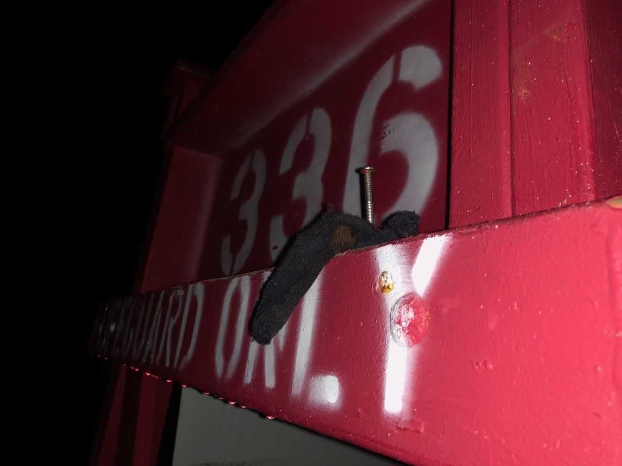

Exhibit 2

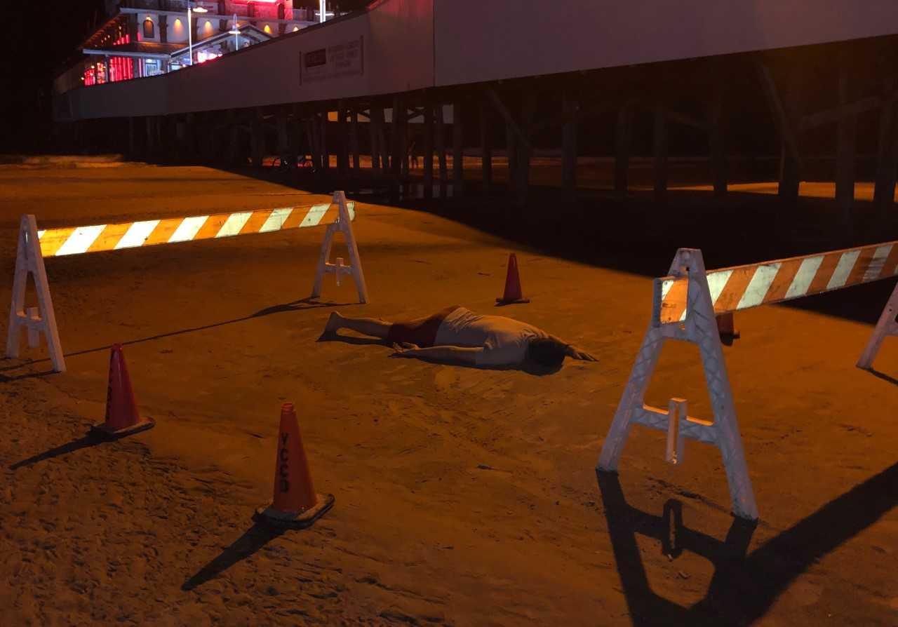

Exhibit 3

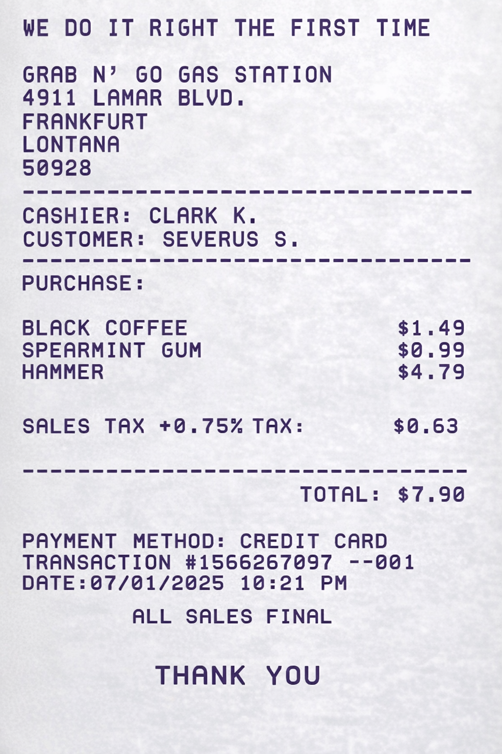

Exhibit 4
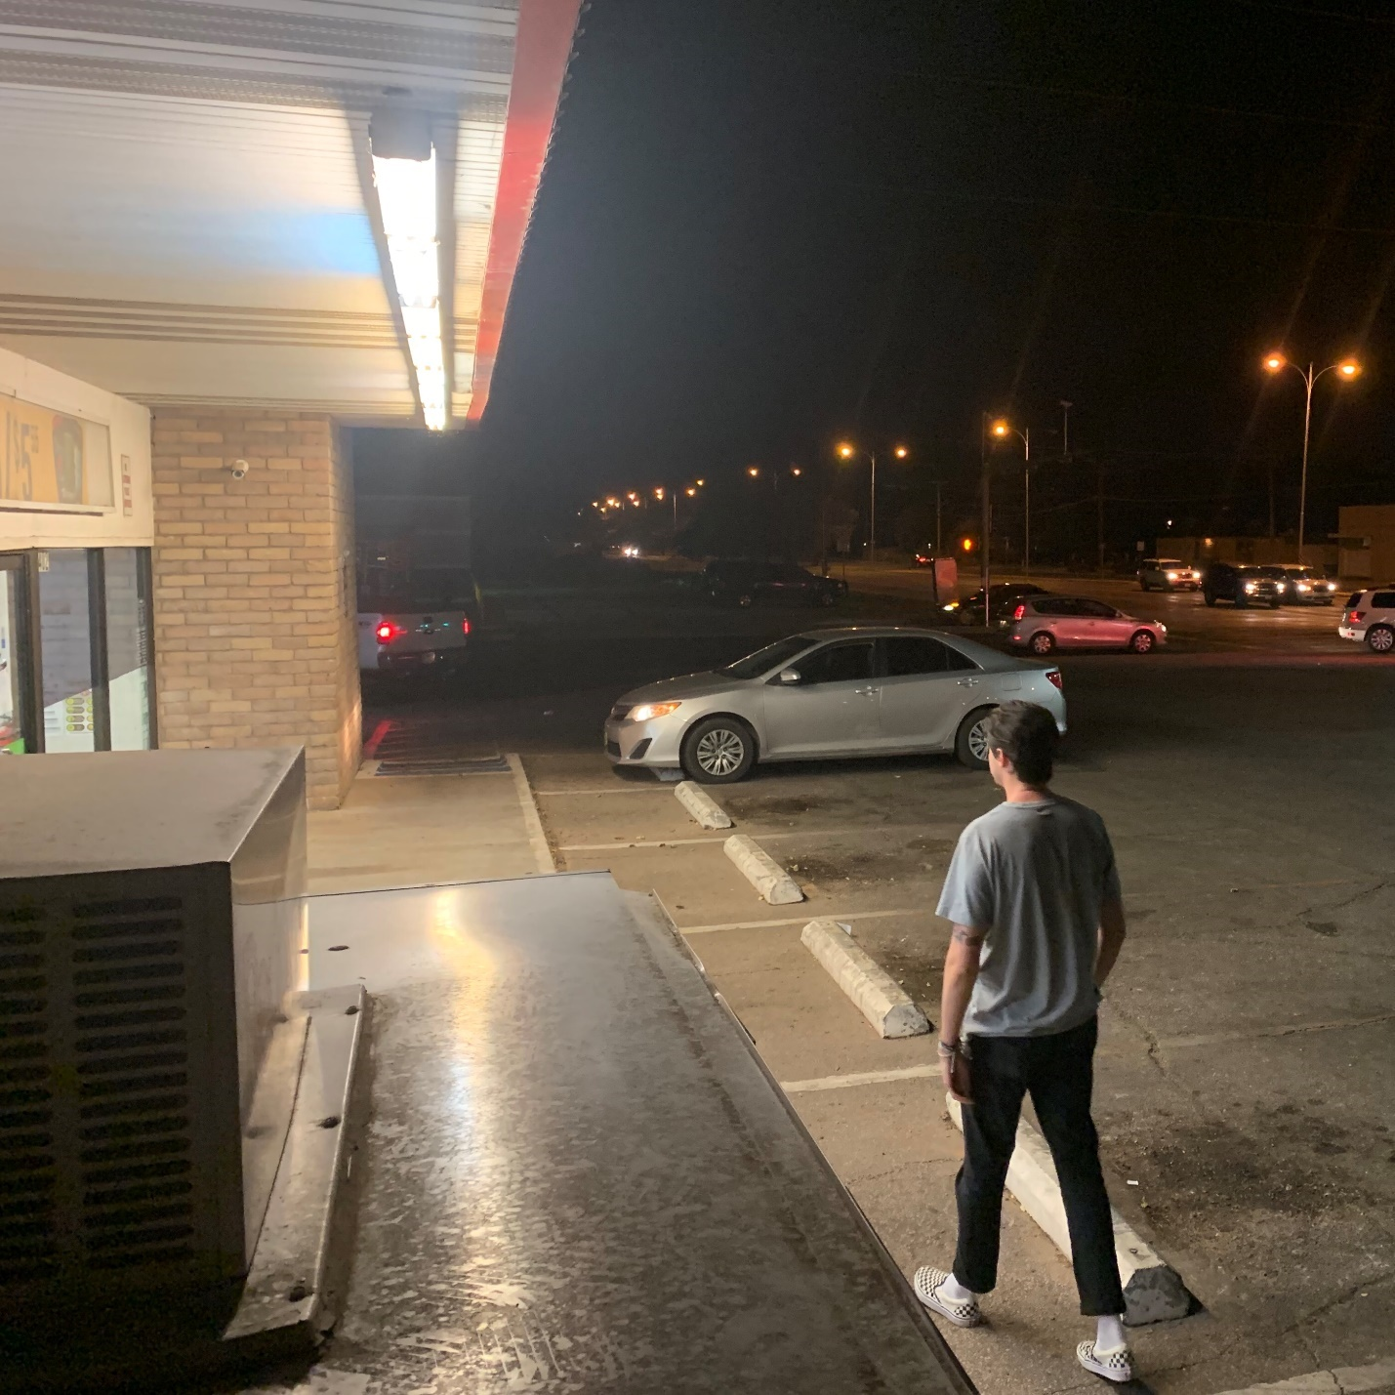

Exhibit 5
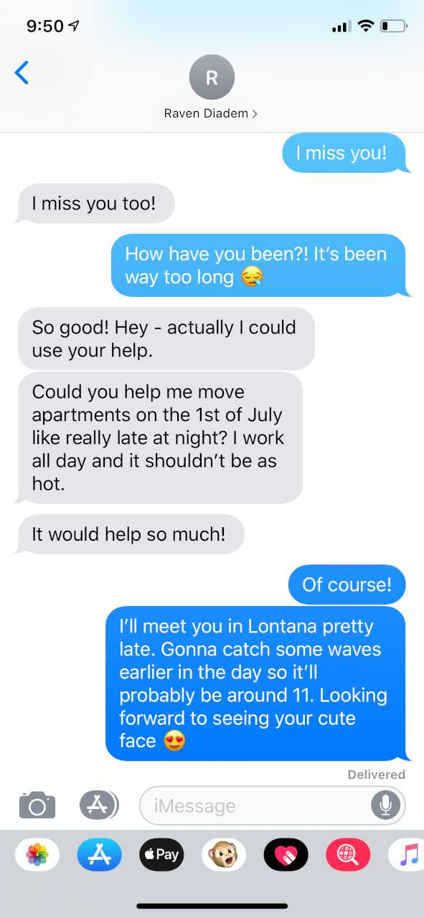
Exhibit 6
44
Hogsmeade, 31.94.4029
DNA ANALYSIS REPORT
By order of the Hogsmeade Police Department I was requested to perform a DNA test on sample #50294 from the Dumbledore crime scene.

Sample Role Description Match es
#50294 Physical Object Black cloth/wetsuit Severus Snape
#50294 Physical Object Black cloth/wetsuit Unidentified Male
#50294 Physical Object Black cloth/wetsuit Unidentified Male

Regarding the sampling of the object please refer to appropriate code. I received the original sample from the Police Department.
Method: DNA isolation was carried out separately for this sample. Genetic characteristics were determined by the following PCR-single-locus-technology analysis.
In parallel, positive and negative controls were performed which gave expected and correct results.
Matching analysis resulted in a 100% match to Severus Snape. Two unidentified males appeared in the DNA analysis. Systems could not match identity to the two males as DNA cultivation was inhibited by outside contamination.

Prepared and reported by Hermione Granger
*DISCLAIMER: All results are subject to the availability of information able to be obtained from said samples. Variation in sampling is regular and highly dependent on systems used and sample tested.

Exhibit 7
DETAILED ANALYSIS AND STATISTICS
Matching resulted in 100% match to three men.
- Severus Snape
- Cedric Hollow
- Neville Clearwater
This report was prepared at the request of Heather R. George, attorney and counselor for Severus Snape.
This report was prepared in anticipation of trial.
Previous reports prepared proved to be an inadequate application of the appropriate methods to retrieve sufficient DNA evidence from received samples.

__________________________________________
Ginny Weasley
DNA Analysis Expert
(806) 000-0101
DNA Report and analysis abstract
Source: DNA statistics performed on state-of-the-art analysis mechanism. Method used flocked swabbing with breaking point and 2ml Eppendorf DNA LoBind tube, in sterile paper-plastic pouch, for forensic use – laboratory sampling.

Sample |  | X |  | Y |  | MATCHING
Wetsuit |  |  |  |  |  | Neville Clearwater,
Severus Snape,
Cedric Hollow
 | 493 |  | +13
 | 210 |  | +0
 | 596 |  | +0
 | 20 |  | +4
 | 53 |  | +0
 | 11 |  | -8
 | 4 |  | +5
 | 52 |  | +1
ARC:740382

Test resulted in a 100% match to three males. All three males placed sufficient trace DNA onto sample to be evaluated.
Previous evaluation of this evidence proved to be insufficient. Use of proper swabbing technique allowed for additional identification of male DNA.
Sample was received from the Hogsmeade Police Department for secondary DNA analysis. Proper permits were secured and presented.

*DISCLAIMER: All results are subject to the availability of information able to be obtained from said samples. Variation in sampling is regular and highly dependent on systems used and sample tested.
Exhibit 8
Analysis of Bleach
Following is a chemical analysis of the bleach found on scene. Sample #50295, which consisted of a portion of Albus Dumbledore’s stained clothing, was analyzed in a fully equipped lab with the appropriate equipment required to do so.
Preliminary Observations:
Sample #50295, a cut portion of Dumbledore’s shirt, appeared to have been stained by direct contact with bleach. Sand covered the article of clothing but has not ruined the ability to analyze chemical makeup. A strong smell of household bleach filled the room when the evidence bag was opened.
Lab Testing:
Using the Jordania Lab-Tech chemical analysis machine, we isolated the unknown substances from the known to further analyze the bleach apart from any contaminants. After successful extraction of the appropriate substance, the portion of the article containing the questionable contaminants were analyzed using the machine. As is found in typical bleach, similar results were apparent here. These results followed:
- sodium hypochlorite
- sodium chloride
- hydrogen peroxide
- calcium hypochlorite
- pH 13
- Foxtail dye
Traditionally, identification of different types of bleach can be difficult. However, identification of this bleach is simple because TT’s Low-Cost Bleach adds an identifier in their chemical makeup.
Because no other bleach on the market, that is known of, adds foxtail dye to their formula, the bleach used at the crime scene has to be TT’s Low-Cost Bleach.

Prepared by Hogsmeade Forensic Department
IDENTIFICATION CODE 60104

Exhibit 9
Evidence: Summary Autopsy Report
Office of the Hogsmeade County Coroner
DATE and HOUR AUTOPSY PERFORMED:  7/03/2025; 8:30 A.M. by  Myrtle Elizabeth Warren, M.D.  1234 Main Street  Hogsmeade County, Lonestar 79414  636-456-7652 (FAX 636-456-7653) | 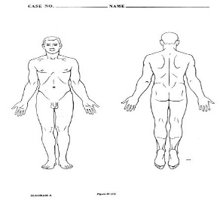  Assistant:  Argus Filch, M.D.  Full Autopsy Performed
SUMMARY REPORT OF AUTOPSY
Name:  Dumbledore, Albus | Coroner's Case #:  2004-277
Date of Birth:  3/23/77 | Age:  48
Race:  White | Sex:  Male
Date of Death:  7/02/2025 | Body Identified by:  Olivander, friend of the deceased
Case #  CR-04-9182 | Investigative Agency:  Lonestar Police Department
I performed an autopsy on the body of Albus Dumbledore at the Department of Pathology, Hogsmeade Hospital, Hogsmeade County, Lonestar on July 3, 2025.
From the anatomic findings and pertinent history, I ascribe the death to: CYANIDE POISONING
EXTERNAL EXAMINATION:
The autopsy is begun at 8:30 A.M. on July 03, 2025. The body is presented in a black body bag. The body is that of a well-developed, very well-nourished Caucasian male state to be 42 years old. The body weighs 168 pounds, measuring 71 inches from crown to sole. The hair remaining on the scalp is white and straight. The irises appear blue with pupils fixed and dilated. The body is cold and unembalmed. The head is normocephalic, and there appears to be no injuries to the head.
INTERNAL EXAMINATION:
HEAD—CENTRAL NERVOUS SYSTEM:
The brain weighs 1255 grams. There are no fractures of the bones of the calvarium or base of the skull.
Upon removal of the victim’s clothing, an odor of bleach was detected. Areas of the body were swabbed and submitted for detection of hypochlorite. There appeared to be scratches on the body of the victim, these scratches are likely the result of a fight that occurred prior to the death of the victim.
The genitalia are that of an adult male and there is no evidence of injury. Limbs are equal, symmetrically developed and show no evidence of injury. The fingernails are medium length and fingernail beds are blue. There are particles under the nails which indicate that the victim had likely scratched at something prior to death. It appears as if the skin samples under the nails are soaked in a corrosive substance. Further analysis proves it was bleach. Samples of the particles were taken to be tested. There are no residual scars, markings or tattoos.
INTERNAL EXAMINATION:
HEAD--CENTRAL NERVOUS SYSTEM: The brain weighs 1255 grams and within normal limits.
RESPIRATORY SYSTEM--THROAT STRUCTURES: The oral cavity shows no lesions. There is no obstruction of the airway. No injuries are seen.
The lungs weigh: right, 355 grams; left 362 grams. Lungs are unremarkable.
CARDIOVASCULAR SYSTEM: The heart weighs 253 grams and has a normal size and configuration. No evidence of atherosclerosis is present.
GASTROINTESTINAL SYSTEM: The mucosa and wall of the esophagus are intact and gray pink, without lesions or injuries.
URINARY SYSTEM: The kidneys weigh: left, 107 grams; right, 110 grams. The kidneys are without lesions.
TOXICOLOGY: Sample of right pleural blood and bile are submitted for toxicologic analysis.
LABORATORY DATA
Cerebrospinal fluid culture and sensitivity:
Gram stain: Unremarkable
Culture: No growth after 72 hours
Hypochlorite: Positive
Cerebrospinal fluid bacterial antigens:
Hemophilus influenza B: Negative
Streptococcus pneumoniae: Negative
N. Meningitidis: Negative
Neiserria meningitidis B/E. Coli K1: Negative
Cyanide Blood Level: 3 mcg/ML (114 micromol/L)

Drug Screen Results:
Urine screen {Immunoassay} was NEGATIVE.
Ethanol: 0 gm/dl, Blood (Heart)
Ethanol: 0 gm/dl, Vitreous
Particle Sample Results:
Particles under nails appears to be human tissue.
Remus Lupin, Ph.D.
Chief Toxicologist
July 10, 2025:
EVIDENCE COLLECTED:
1. One (1) white shirt, size Large.
2. One (1) pair red shorts, size Large.
3. One (1) pair of navy blue boxers, size Large.
5. Samples of Blood (type O+), Bile, and Tissue (heart, lung, brain, kidney, liver, spleen).
6. Fifteen (15) swabs from various body locations, to be tested for presence of hypochlorite.
7. Ten (10) collection of particle samples underneath nails of Victims hands.
7. Eleven (11) autopsy photographs.
8. One postmortem CT scan.
9. One postmortem MRI.
OPINION
Time of Death: Body temperature, rigor and livor mortis, and stomach contents approximate the time of death between 1:30 and 2:00 A.M. on 7/02/2025.
Immediate Cause of Death: Death by cyanide poisoning.
Manner of Death: Homicide
Remarks: The appears to be large amounts of hypochlorite found on the Victims body. The hypochlorite was likely used to remove any evidence of the Homicide from the Victims body. It appears as if the skin samples under the nails are were destroyed due to the hypochlorite found on the Victim’s body. The remainder of the autopsy revealed a normal, healthy adult male with no congenital anomalies.
// Myrtle Elizabeth Warren, M.D.
Hogsmeade County Coroner's Office
July 13, 2025

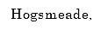
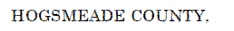
Exhibit 10
Exhibit 11
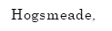
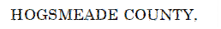

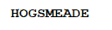
Exhibit 12
Exhibit 13

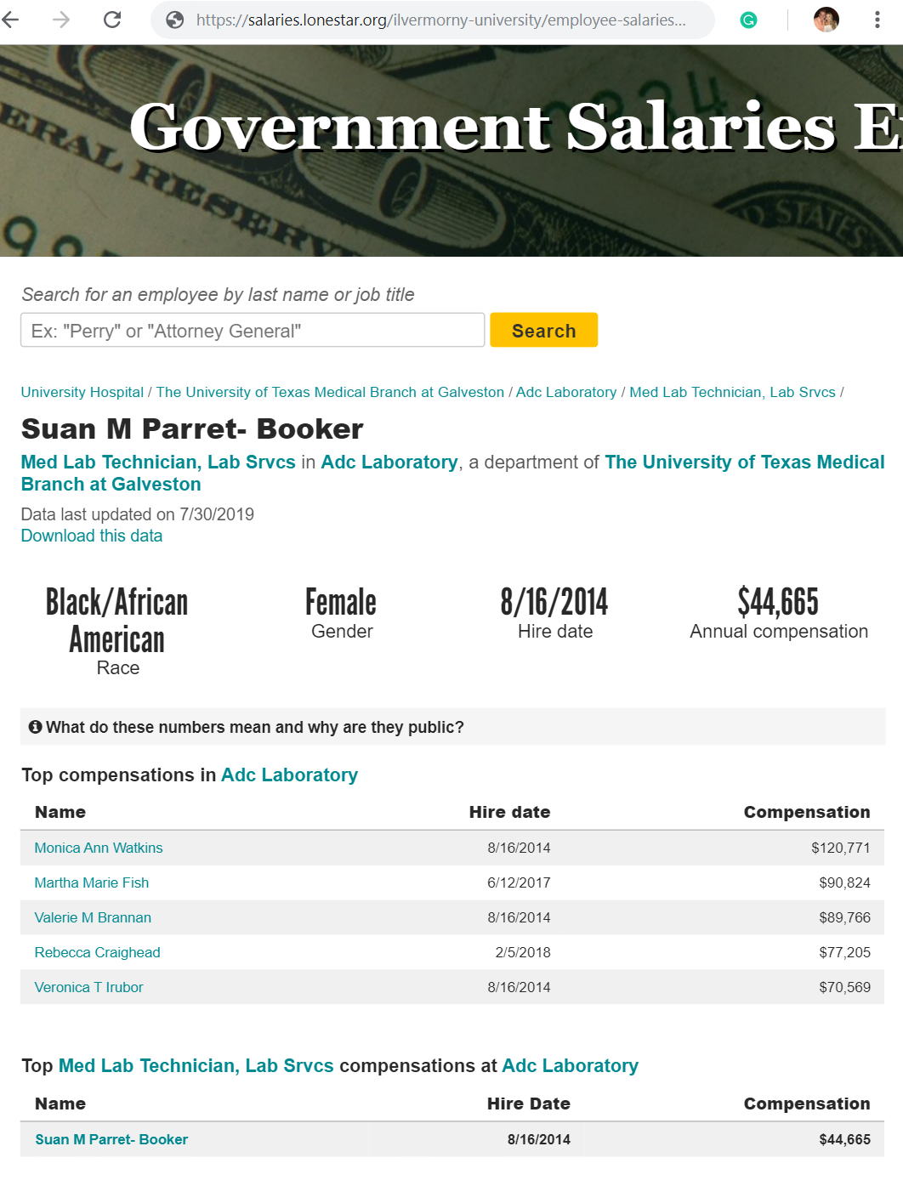
Gellert Gribenwad 6/15/1987 $32,312 $263,482
The Lonestar Tribune obtained this information under the Lonestar Public Information Act. This database presents information as the entities provide it, with the exception of aggregations and visualizations created by the Tribune. Have questions or concerns? Please take a look at commonly asked questions about the Government Salaries Explorer.

Tom Puzzle 3/02/2004 $84,891
Severus Snape 3/18/2013 $64,000
Luna Lovebad 7/13/2001 $179,540
Albus Dumbledore 1/21/1984 $263,482
Ilvermorny University Laboratory Department
Ilvermorny University / Laboratory / Employees / Annual Salaries
FULL TIME EMPLOYEES
Laboratory Staff, Laboratory, at Ilvermorny University
Data last updated 6/30/2025
Download this data

Exhibit 14



No. CR-04-9182
HARRY POTTER § IN THE DISTRICT
Plaintiff, § COURT
§
§
§
§ IN AND FOR
v. §
§
§
§
SEVERUS SNAPE § HOGSMEADE COUNTY,
Defendant. § LONESTAR

FINAL JURY INSTRUCTIONS
Members of the jury, I shall now instruct you on the law that you must follow in reaching your verdict. It is your duty as jurors to decide the issues, and only those issues, that I submit for determination by your verdict. In reaching your verdict, you should consider and weigh the evidence, decide the disputed issues of fact, and apply the law on which I shall instruct you to the facts as you find them, from the evidence.

The evidence in this case consists of the sworn testimony of the witnesses, all exhibits received into evidence, and all facts that may be admitted or agreed to by the parties. In determining the facts, you may draw reasonable inferences from the evidence. You may make deductions and reach conclusions which reason and common sense lead you to draw from the facts shown by the evidence in this case, but you should not speculate on any matters outside the evidence.

In determining the believability of any witness and the weight to be given the testimony of any witness, you may properly consider the demeanor of the witness while testifying; the frankness or lack of frankness of the witness; the intelligence of the witness; any interest the witness may have in the outcome of the case; the means and opportunity the witness had to know the facts about which the witness testified; the ability of the witness to remember the matters about which the witness testified; and the reasonableness of the testimony of the witness, considered in light of all the evidence in the case and in light of your own experience and common sense.

The issues for your determination are (1) whether the death of Albus Dumbledore was caused by the intentional actions of defendant Severus Snape, (2) whether Severus Snape demonstrated a clear intent to willfully, wantonly, and maliciously injure Albus Dumbledore, (3) whether Albus Dumbledore’s own fault or negligence contributed to his death and 4) the percentages of fault of each individual.

In that regard, you are instructed that plaintiff Harry Potter has the burden of proof on the fault claim against Severus Snape, meaning that Harry Potter must convince you by a preponderance of the evidence that Albus Dumbledore’s death was the result of Severus Snape’s fault, if any. You are further instructed that Severus Snape has the burden of proof on the claim that Albus Dumbledore’s death was caused in whole or in part by his own fault or negligence, if any.

If you find by the greater weight of the evidence that the actions of Severus Snape, were intentional and demonstrated a clear intent to willfully, wantonly, and maliciously injure Albus Dumbledore, which actions constituted a gross disregard for the safety of Albus Dumbledore, causing Albus Dumbledore’s death, then you must find that Severus Snape intentionally caused the death of Albus Dumbledore. If you so find, you must find for Harry Potter and indicate this on your verdict and inform the bailiff that you are ready to return to the courtroom. Should you find for Harry Potter, you will return to the courtroom and hear from additional witnesses and presentations from attorneys concerning damages that may be awarded.

You are instructed that the term “negligence” or fault means failure to use ordinary care, that is, failing to do that which a person of ordinary prudence would have done under the same or similar circumstances or doing that which a person of ordinary prudence would not have done under the same or similar circumstances.

“Ordinary care” means that degree of care that would be used by a person of ordinary prudence under the same or similar circumstances.

“Proximate cause” means that cause which, in a natural and continuous sequence, produces an event, and without which cause such event would not have occurred. In order to be a proximate cause, the act or omission complained of must be such that a person using ordinary care would have foreseen that the event, or some similar event, might reasonably result therefrom. There may be more than one proximate cause of an event.

At this point in the trial, you, as jurors, are deciding if Albus Dumbledore’s death was caused, in whole or in part, by the intentional actions of Severus Snape, the negligence of Albus Dumbledore himself, or a combination of the two.

Your verdict must be based on the evidence that has been received and the law on which I have instructed you. In reaching your verdict, you are not to be swayed from the performance of your duty by prejudice, sympathy, or any other sentiment for or against any party. When you retire to the jury room, you should select one of your members to act as foreperson, to preside over your deliberations, and to sign your verdict. You will be given a verdict form, which I shall now read and explain to you.

(READ VERDICT FORM)

When you have agreed on your verdict, the foreperson, acting for the jury, should date and sign the verdict form and return it to the courtroom. You may now retire to consider your verdict.

No. CR-04-9182
HARRY POTTER § IN THE DISTRICT
Plaintiff, § COURT
§
§
§
§ IN AND FOR
v. §
§
§
§
SEVERUS SNAPE § HOGSMEADE COUNTY,
Defendant. § LONESTAR

VERDICT
WE, THE JURY, RETURN THE FOLLOWING VERDICT:

- Were the actions of Severus Snape intentional and demonstrated a clear intent to willfully, wantonly, and maliciously injure Albus Dumbledore, causing the death of Albus Dumbledore?
YES __________ NO __________

If your answer to question 1 is YES, your verdict is for the plaintiff and you should not proceed further except to date and sign this verdict form and return it to the courtroom. If your answer to question 1 is NO, please answer question 2.

- Was there negligence on the part of Severus Snape which was a legal cause of the death of Albus Dumbledore?
YES __________ NO ___________

If your answer to question 2 is NO, your verdict is for the defendant, and you should not proceed further except to date and sign this verdict form and return it to the courtroom. If your answer to question 2 is YES, please answer question 3.

- Was there an assumption of risk or negligence on the part of the deceased, Albus Dumbledore, which was a legal cause of his death?
YES __________ NO ___________

continued on page 2

If your answer to question 3 is YES, please answer question 4. If your answer to question 3 is NO, do not answer question 4 and sign and date the verdict form.

- State the percentage of any negligence, which was a legal cause of Albus Dumbledore 's death, that you charge to:

SEVERUS SNAPE ________%
ALBUS DUMBLEDORE ________%

The total of the two percentages must equal 100%.

CERTIFICATE

We the jury have answered the above and foregoing questions as herein indicated, and herewith return same into Court as our verdict.

_____________________________
Presiding Juror

