23-24
Advanced Negotiations
For the Competitor

Welcome to the Advanced Negotiations competition!
Thank you for competing with us. The following materials are meant to help guide you in your competition but remember that they’re only a guide. If you want to do something different or if your coach recommends a different route, you are more than welcome to pursue that.
If you elected to have a coach, please ask them any questions you may have. They have valuable experience that can help you. Keep in mind that your coach may not help you on substantive issues. For Negotiations, that means they can’t help you with deciding what to offer or anything else related to the content of the problem. Ask your coach questions relating to the format of the competition, style, or feedback on performance. Your coach will watch at least one of your preliminary rounds. Speak with them after! That is where many people get their most valuable feedback.
What does the Negotiations competition look like?
Advanced Negotiations starts with the preliminary rounds (“prelims”). The preliminary rounds are the first three rounds you participate in. After each round, the judge of that round will fill out a ballot, determining which side won that round. These ballots become available for you to access after the preliminary rounds are concluded and the next rounds for those who advanced (“broke”) are announced. You are strongly encouraged to look at those ballots. They can offer incredibly valuable insight.
Everyone who competes in the Negotiations prelims will receive 10 BoB points. Those who do not break will receive 1 additional point for each prelim round they won. Those who do break will receive an additional 5 points for each round they advance to.

How far they advanced | Competitor | Points
Didn’t break but won one prelim round | Khusbu Shah | 11
Broke to octa finals but didn’t win | Cassidy Monska | 15

If you have questions about points, contact the Vice Chair of Competitors, Khusbu Shah. Her email is khusshah@ttu.edu.

What does a Negotiations round look like?
Before each Negotiations round, you will be given a set of facts including general facts and confidential facts. General facts are given to both parties. Confidential facts are only given to your side. Be strategic on how you use that information.
You should show up to your Negotiations round in business professional dress and 15 minutes early. This gives you time to find your room and prepare your materials. You may bring a copy of your facts, both general and confidential, and a legal pad or scratch paper to write on. You may have an initial offer written down for your own purposes but do not give any additional materials to your opposing team.
Once your judge arrives, each side will do a “pre-negotiation.” Pre-negotiations are 5 minutes alone with the judge to discuss what your goals and expectations are for the round. You should have your pre-negotiation memorized but be as relaxed as possible so that is sounds conversational. Tailor your pre-negotiation to your client’s goals and interests and how you can best act to achieve those goals. You have been provided a pre-negotiation script at the end of this packet, but please remember that it is a jumping-off point. If it doesn’t work for you, change it so that you can address your client’s goals and your strategy to achieve them but in your own words. Judges will appreciate variety in how pre-negotiations are given so that it sounds genuine to you. The pre-negotiation should be delivered while standing.
You will have 5o (fifty) minutes to negotiate. You will be responsible for keeping your own time. You may wear a watch or keep your phone with a timer facing upwards on the table. Your phone should only be used to keep time.
You may spend your 50 minutes however you like but most negotiations begin with introductions and setting an agenda for the round then fact finding. When you introduce yourself, follow the lead of the facts. If the facts say you have been working with the opposing side for a while, mention that is nice to see them again. Setting the agenda helps set a structure to follow during the round while making sure the round goes efficiently. If the problem includes complex facts, you should consider writing the agenda and offers on a whiteboard but don’t allow it to become a distraction during the round.
Typically after an agenda is set, each side will ask the other questions to get a better sense of what each side is working with which is also known as Fact Finding. Fact finding is a crucial part of the negotiation process, and is necessary to understand the full scope of facts prior to negotiating. If you are asked a question, you must answer it honestly, but if there is room to be evasive it may serve you to do so.
Then each side will put out their initial offers. For each offer, you should try to provide a justification behind that offer. This shows both your opposing team and your judge that you recognize your client’s strong points and weak points and you are very familiar with the problem. Each term that your client wants to be addressed should be addressed. Prior to ending the negotiation, you should review the terms with the opposing side so that you both are on the same page.
NOTE: Although you will be judged holistically, the outcome now plays a role in determining the results of the round.
Each side is allowed a 5 minute break during the round, which is included in the 50 minutes of the round, and can be used as a strategic step in the negotiation.
Once the negotiation concludes, each side will get 5 minutes to prepare for their “post-negotiation.” Post-negotiations are another 5 minutes alone with the judge to discuss the deal you reached and your thought process that led to those final terms. You should explain all the terms and briefly explain why you agreed to that term, particularly if it was a concession. Explain how the terms fit your parameters. Then, you should address some things you did well and some things you can improve on. You may be asked questions. Answer them in a friendly manner. View them as an opportunity to explain rather than defend. Remember to deliver your post-negotiation while standing. While the other side is doing their post-negotiation, you may not prepare for your own.
What is an ethical violation?
Ethical violations are most common in Negotiations and can arise fairly easily if you are not paying attention. For the Board of Barristers competitions, an ethical violation occurs when you agree to a term that you were not permitted to do under the facts provided or you deliberately behave in a way that is unethical like lying through commission or omission. An ethical violation does not occur if you agree to a term that is on the lower end of what your client wants. An ethical violation does not occur if you are not able to reach a deal (but you should still try to). An ethical violation does occur if you agree to a term that your client explicitly stated they did not want. An ethical violation does occur if you lie. If you are familiar with your facts and careful with your words, you should not encounter an ethical violation.
Ethical violations will result in points being deducted from your ballot. The amount of points deducted will depend on the violation. Violations that are deliberate attempts to deceive will result in more points lost than mistakes. The amount of points deducted will be determined on a case-by-case basis.

Resources
Pre-Negotiation Script
“Good [morning/afternoon], my name is [your name] and my negotiation partner is [negotiation partner’s name]. We are here today to represent [client’s name] in a negotiation with [opposing side’s client’s name].
We have been asked to address two questions prior to the negotiation to assist you in your analysis of our performance moving forward.
The first question is: “What are our client’s main goals and interests for the negotiation?”
NOTE: Be conversational here! Address what your client is most concerned with. This could be a great opportunity to introduce your judge to your client.
The second question is: “What is our overall negotiation strategy and why?””
NOTE: Choose a negotiation strategy that works for your position and your personality. If it would not be natural for you to be aggressive, even if you have great points, don’t do it. The strategies that you can use based on your problem include “collaborative”, “competitive,” “compromising”, “avoiding”, and “accommodating”. You want to pick a strategy that you can actually use in the heat of the round, not just something that sounds good to a judge. If you don’t use it in the round after you said you would in your pre-negotiation, be prepared to be questioned about it in post.
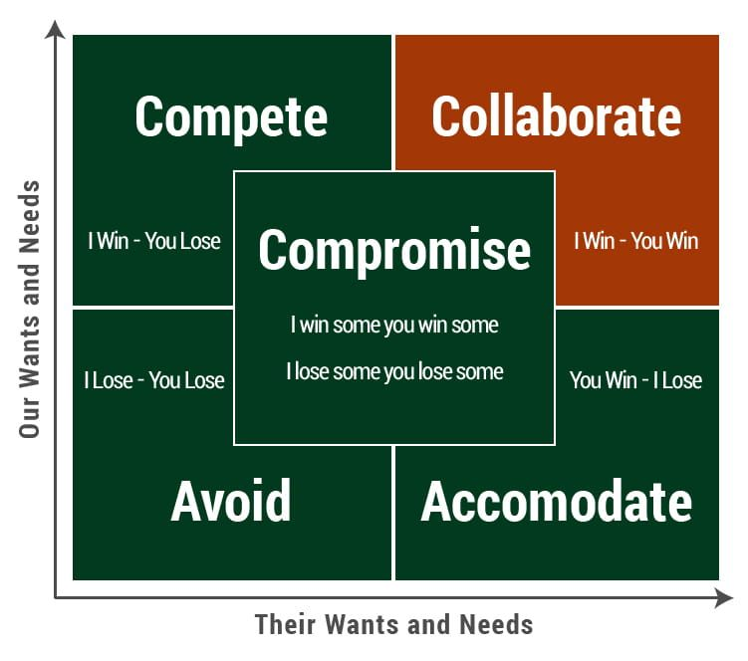

Post-Negotiation Script
“Good [morning/afternoon], my name is [your name] and along with my negotiation partner, [negotiation partner’s name], we represented [client’s name] in a negotiation with [opposing side competitor] and [opposing side competitor], representing [opposing side’s client’s name].
We have been asked to answer a two-part question during this post-negotiation analysis:
“In reflecting on the entire negotiation, if faced with a similar situation tomorrow, what would we do the same and what would we do differently?”
First, if faced with a similar situation, there are several things that we would do the same.
NOTE: Try to give a few (at least two) good examples from the round that relate to your flexibility, your advocacy for your client, your teamwork, and your relationship to the opposing side. Point out the favorable terms or creative solutions you came to.
Of course, no negotiation is perfect, so if we were faced with this situation again, there are some things we could improve on.
NOTE: Acknowledge places where you didn’t perform as well as you wanted to. This may relate to how much time you spent on certain terms or information gathering. Be realistic here. Your judge may ask you questions about these things. Remember to be polite and not defensive.
All of our terms stayed within our client’s bounds.”
NOTE: End with an impact statement, like “Our client walked out with a great deal” or “Although we didn’t reach a deal today, we fought for our client and when we come back to the table that won’t change.”

GENERAL NOTE: You are still required to answer the questions and address the topics included in the script, but you are not required to stick to verbiage or order included within that script.

